Building the

Izenda Custom Data Source Adapter

Contents

Introduction 5

Izenda Data Source Adapter Overview 5

The Concept in Data Source Adaptor 8

Query Source Field 8

Query Source 8

Query Source Category 8

DBSource 9

Query Source Parameter 9

SQL Query Source Type 9

Relationship 9

The connection 9

Mapping between RDBMS Concept and Izenda Data Source Provider Concept 9

Izenda Fusion Module and Query Tree 10

Query tree Node 10

SQL Command Generators 11

Operator Command Generator 11

Filter Command Generator 14

Calculated Command Generator 15

Izenda Raw Query 17

Naming Identifier 18

IZENDA_CONCAT function 18

DATETUNCATE function 19

IDataSourceAdaptor Interface 19

Crossing Concern Members 19

LogManager Property 19

Get connection information 20

TestConnection(Guid, string) 20

GetDatabaseServer(string) 20

GetDatabaseName(string) 20

GetConnectionStringWithServerAndDatabaseName 20

Load Data Source Schema Definition 21

LoadDatabaseSchema(string) 21

LoadFields(string, string, string, string, bool, List<QuerySourceParameter>, bool, int, ILog) 21

GetQuerySourceParameters(string) 22

GetQuerySourceParameters(List<QuerySourceParameter>, string, string, string, QuerySource) 22

LoadConnectionDetail(Connection, bool, string, ILog) 22

GetExtendedProperties(string) 23

GetSupportedDataSourceType(string) 23

GetBaseDataTypes(string) 23

LoadCustomQuerySourceFields(string, string) 23

Execute SQL commands and query data 24

Query(string, string, object, int) 24

Query(string, string, string, string, string) 24

Query(stirng, QueryTreeNode, FusionContextData) 25

CanQuery(QueryTreeNode, FusionContextData, string) 25

Execute(string, string, List<dynamic>) 25

GetFirstValueInFilteredValue(string, string) 26

QueryMultiple(string, string, object, int, Action<SqlMapper.GridReader>) 26

Specific Configuration for RDBMS in Adaptor Component 27

Data Types 27

DatabaseSupportDataType class 28

Database Functions 29

Database Functions Format 31

Database Constants 34

Select Field Command Format 35

Query Normalizer 35

Preparation for New Data Source Adaptor 36

Download dependency components 36

Create Query Normalizer Component 37

General Purpose 37

Analysis to implement Query Normalizer Activity 37

Create Izenda.BI.QueryNormalizer.Redshift Library 37

Create abstracted class RedshiftQueryNormalizerActivity 39

Add class RedshiftEscapseTableNameActivity 39

Add class RedshiftReplaceConcatFunctionActivity 40

Add class RedShiftReplaceDateTruncateFunctionActivity 42

Write your custom Query Normalizer Activity 42

Create Data Source Adaptor for Redshift 43

Identify Data Provider 43

Dapper Usage 44

Create new Adaptor Project 44

Add Project Dependency 45

Configure Data Types and Build-in Functions 47

Data Types 47

Database Functions 49

Database Function Format 50

Database Constants 51

Implement connection handler class 51

Implement schema loader class 54

ISchemaLoader interface and implementation 54

GetQuerySourceParameters(string) 56

GetQuerySourceParameters(string, string, string) 56

LoadCustomQuerySourceFields(string, string) 57

LoadQuerySourceField(string) 58

LoadSchema(string) 59

LoadFields(string, string, string, string, bool, List<QuerySourceParamter>, bool, int, ILog) 61

LoadRelationship(string, List<string>) 63

Implement Data Source Adaptor class 64

Declare adaptor class and exported configuration 64

Override SchemaLoader and Connection Property 65

Override NormalizeQuery(string) Method 65

Override GetConnectionStringWithServerAndDatabaseName(string) Method 66

Override GetFirstValueInFilteredQuery Property 66

Override GetBaseDataTypes() Method 66

Override Query(string, string, object, int) Method 67

Override QueryMutiple(string, string, object, int, Action<SqlMapper.GridReader>) Method 67

Override QueryTreeCommandGenerator Propery 68

Implement Custom Operator Command Generators 70

Operator Command Generators Are Required to Override 70

Overriding Other Operator Command Generators 75

Register Operator Command Generator in Visitor Class 76

Implement Expression Command Generator 78

Analysis Overriding Expression Command Generator 78

Add generator and visitor class 79

Implement Filter Generator 79

Create Redshift Data Source Adaptor Using ODBC Driver 79

Introduction and Analysis 79

Install Amazon Redshift ODBC Driver 79

Implement Adaptor with OdbcConnection 79

RedhisftConnection class 79

RedhisftSchemaLoader class 79

RedshiftDataAdaptor class 79

Troubleshooting When Developing New Data Source Adaptor 79

Debugging on Data Source Adaptor 79

Investigate Issue by Analysis Izenda Log 79

Troubleshooting for Limitation on ODBC Driver 79

Testing New Data Adaptor From Izenda UI 79

Connection String 80

Data Model 81

Report 82

Case 1: Global report contains tenant field 83

Case 2: Report with filters 86

Case 3: Report with grouping, aggregated function and sub total 87

Case 4: Report with Calculated Field 89

Case 5: Drilldown chart report part 90

Case 6: Exporting report 91

# Introduction

This guide will give you an overview of the major aspects of an Izenda Data Source Adapter.

The purpose of the guide is to abstract from the core of the Redshift ODBC Data Source Adapter guide the overarching concepts of custom data source adapter.

# Izenda Data Source Adapter Overview

Izenda Data Source Adaptor is part of Izenda system provides communication between RDBMS Data Source and Izenda reporting logic. It takes responsibility for querying report data and calculate data aggregation and combine with Izenda Business Layer to enable data access and data manipulation capabilities on specific RDBMS data server.

The Data Source Adapter component handles transformation Izenda reporting logic to SQL command of specific RDBMS then specify SQL query command that provide elementary CRUD functionality on data source.

An Adaptor also is used to take care of data source connection in Izenda system and explore data source schema structure and configuration then convert to Izenda abstraction concepts to save on Izenda system database for management data connection as well as process for reporting logic.

Data Source Adapter in Izenda system:

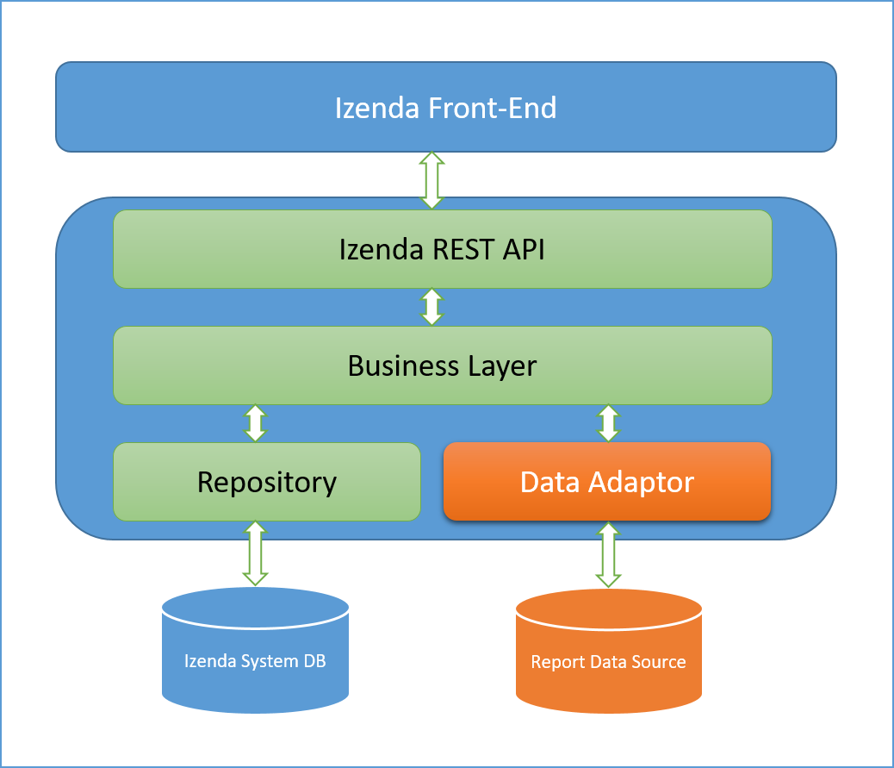

Figure 1: Data Source Adaptor in Izenda System

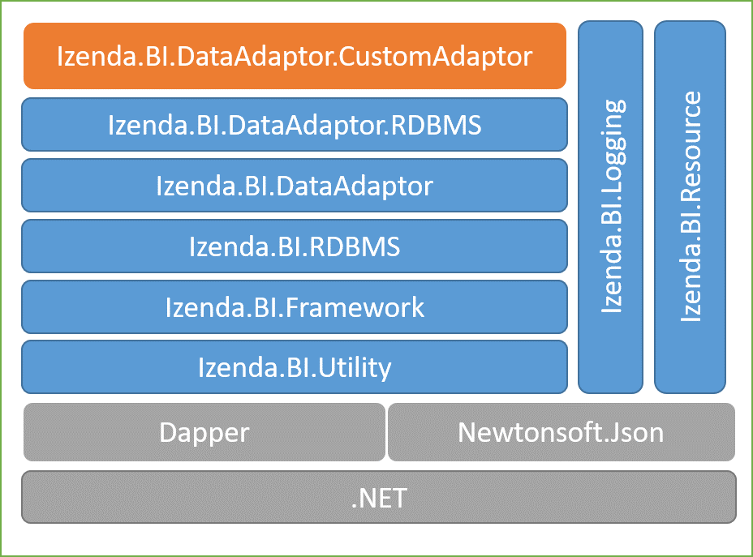Below diagram demonstrate dependency of a Data Source Adapter component. The orange component is your custom data source adaptor.

Figure 2: Dependency component of a Data Source Adaptor

Basically, a custom Data Source Adaptor can be implemented with any architecture as long as it can be get report data and manipulate aggregation calculation on data source of a connection, but look through this guideline, it will be following on architecture that we have used to implement Data Source Adaptor for Izenda system, and a specific Adaptor component should have logical units similar other Izenda Adaptor such as:

* Main Data Source adapter component which is inherited from IDataSourceAdapter interface.
* Connection handler unit to verify and open data source connection as well as collect more information on the connection.
* Data source schema loader to explore data source schema structure and convert to abstraction object that Izenda system can understand.
* The logical for converting reporting logic processing on Izenda Logic Layer to specific SQL command for a database server, that will generate SQL query statement which will be able to run completely on the RDBMS that you are going to develop Adaptor for.

The Data Source Adaptor usually has logical units as diagram below:

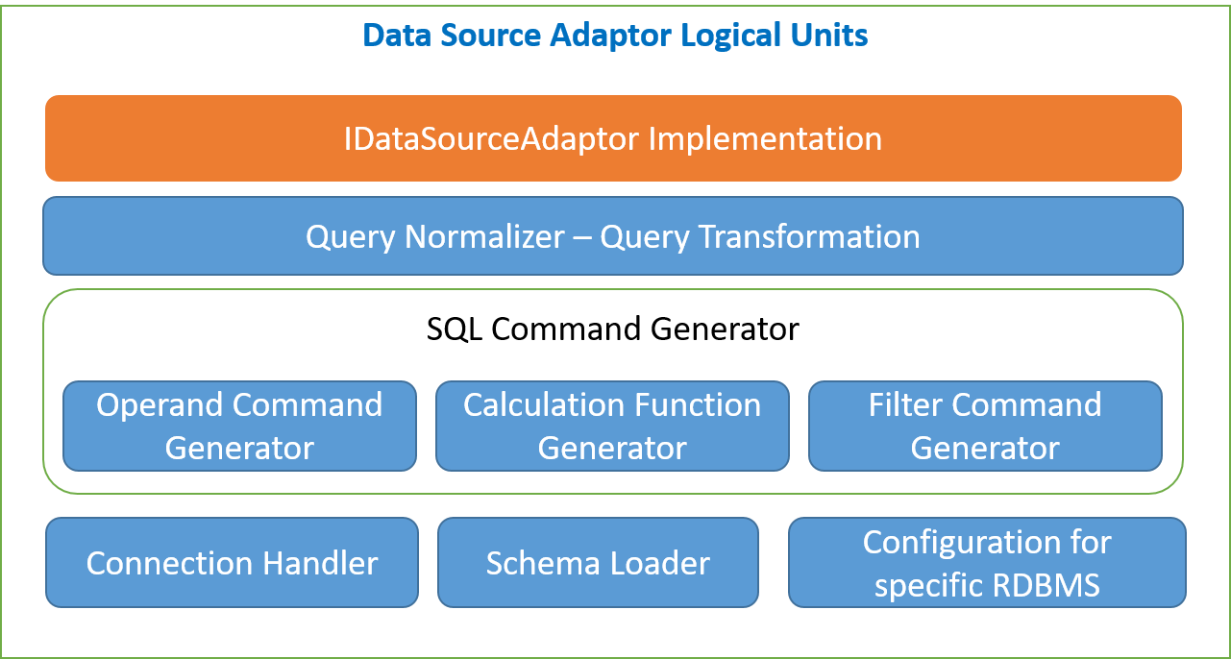

Figure 3: Data Source Adaptor logical units

This table describe usage purpose for each logical unit in above diagram:

|  |  |  |
| --- | --- | --- |
| .No | Logical Unit Name | Description |
| 1 | The class implement IDataSourceAdaptor | The most important unit for an Adaptor can work with Izenda BI system |
| 2 | Query Normalizer – Transformation | Convert or transform Izenda “raw” query to SQL syntax that target RDBMS can execute completely without issue |
| 3 | Operand Command Generator | Unit to generate SQL command for operand that Izenda uses on report. Each operand has corresponding concreate SQL statement |
| 4 | Calculation Function Generator | Izenda uses some built in function in RDBMS on report processor, but if RDBMS does not contain some of that function, we have to create generator to create new corresponding function |
| 5 | Filter Command Generator | On Izenda Report, there are many filters can be applied, this logical unit is using to generate filtering statement in syntax of your RDBMS |
| 6 | Connection Handler | Each RDBMS will have specific data provider to handle opening connection as well as executing data query and data modifying, this component logic will use that data provider to open and verify connection as well as get more information about data source connection |
| 7 | Schema Loader | The unit for exploring data source schema structure convert to Izenda abstraction object such as Query Source, Query Source Field… etc. |
| 8 | Configuration for RDBMS | Each RDBMS has its own separated configuration and feature, this unit will provide configuration to distinguish your RDBMS in concept of supported datatype, build-in function and data formatting |

Table : Description of Logical Units should be contained in a custom Data Source Adaptor

This document will provide detail description for each logical unit in above diagram in separated section, in generally it will describe about concept, the definition and how to implementation as well as how each unit works and effect on Izenda system.

# The Concept in Data Source Adaptor

Beyond introduction, definitions, before going to practice how to create a custom driver, there’s of course an expectation that you need to know some concepts are using in Izenda data source adapter what you might implement in your custom driver.

## Query Source Field

This is fields in the tables/views. Properties are: field name, alias, data type, positon, belong which table and schema, which Izenda data type it maps to …

Reference: LoadFields method in RedshiftSchemaLoader class.

## Query Source

This is the tables or views or functions or store procedures. This is parent of query source field, it contains a list of fields. Properties are: name, id, type (table/view/function/store produce), real name, category …

Reference: GetTables method in RedshiftSchemaLoader class.

## Query Source Category

This is a schema which you retrieve from database, this is parent of query source. Properties are: name of schema, id, parent category… and a list of objects like tables, views, functions, store procedures.

Reference: GetSchemas method in RedshiftSchemaLoader class.

## DBSource

This is whole entry of a database information exclude relationship, this is parent of a schema. It contains a list of QuerySourceCategory.

Reference: LoadSchema method in RedshiftSchemaLoader class.

## Query Source Parameter

This is parameters which are used in queries or filters. Some properties: name, data type, category, position…

Reference: GetQuerySourceParameters method in RedshiftSchemaLoader class.

## SQL Query Source Type

This defines 4 public const strings which were mapped with objects in database are: Table, View, Procedure and Function.

## Relationship

This is relationship between tables or schema. Such as: name of relationship, alias, join type, which report it belongs to…

Reference: LoadRelationships method in RedshiftSchemaLoader class.

## The connection

Izenda provides a fully exposed IConnection, which includes exposed   
TestConnection method uses to test a connection whether success or not. If not, there will return some status codes like invalid server ("08000", "08003",…), invalid database ("3D000") or login fail with credential ("28000", "28P01").  
Besides that, Izenda also provides: OpenConnection, GetDatabaseServer, GetDatabaseName and GetUserName methods, these use to retrieve information about database which you attempt connect to.

Reference: RedShiftSQLConnection.cs

## Mapping between RDBMS Concept and Izenda Data Source Provider Concept

For best understand above concepts, looking to the table below of mapping between RDBMS and Izenda Data Source Provider Concept

|  |  |  |  |
| --- | --- | --- | --- |
| **RDBMS** | **Izenda Data Source** | **Izenda framework model** | **Note** |
| Whole entry database information | DBSource | DBSource.cs class | Exclude relationship |
| Schema | Query Source Category | QuerySourceCategory.cs class |  |
| Table | Query Source | QuerySource.cs class | SQL Query Source Type = Table |
| View | Query Source | QuerySource.cs class | SQL Query Source Type = View |
| Function | Query Source | QuerySource.cs class | SQL Query Source Type = Function |
| Store Procedure | Query Source | QuerySource.cs class | SQL Query Source Type = Procedure |
| Field | Query Source Field | QuerySourceField.cs class |  |
| Parameter | Query Source Parameter | QuerySourceParameter.cs class |  |
| Relationship | Relationship | Relationship.cs class |  |

Table : The mapping between Izenda Query Source concept and RDBMS concept

## Izenda Fusion Module and Query Tree

*This is being documentation…*

## Query tree Node

|  |  |
| --- | --- |
| **Concept** | **Description** |
| Operand | This concept presents the operand operators in the queries. |
| Binary | This concept presents the binary operators in the queries like left and right operation. |
| Conditional | This concept presents the conditional operators in the queries like logic condition and filter condition. |
| ConvertNullToEmpty | This concept presents the convert operator from null data to empty as string in the queries. |
| Unary | This concept presents the unary operator in the queries at one time |
| Join | This concept presents the join operators between 2 or more objects in the queries. |
| Projection | This concept presents the projection operators in the queries. |
| Selection | This concept presents the selection operators in the queries. |
| Union | This concept presents the union operators between 2 or more queries together. |
| Cartesian | **This does not use in any driver for now.** |
| Grouping | This concept presents the group operators in the queries. This instance is to define which fields use to group, re-group or not. |
| Sorting | This concept presents the sorting operators in the queries. This instance is to define which fields use to sort, re-sort or not. |
| GrandTotal | This concept presents the grand total operator. This does not use. |
| SubTotal | This concept presents the sub total operator. |
| GroupPercentTotalField | **This does not use in any driver for now.** |
| ResultLimit | This concept presents the limit result from the returned data in the queries. Example: SELECT TOP X |
| SideTotal | This concept presents calculation for side total operator, indicate which field use to apply for side total operator. |
| PivotColumnLimit | This concept presents limit operators on the pivot column using in report. |
| Distinct | This concept presents the distinct operators in the queries,  indicate fields to distinct operator. |
| Paging | This concept presents the paging operators in the queries, contains information about page index, page size, whether last page or not. |
| Formatting | This concept presents the format information of fields font, size, style for field is applied(grand total field, subtotal field, side total field, side total grouping) |
| GroupPercentNormalField | This concept presents the group percentage operators on normal fields. |
| DefaultPercent | This concept presents the default percentage operators as default. |
| Running | This concept presents for running operators for the queries. Such as which field is pivot field, virtual field, related fields among report …. |
| GroupPercentSideTotal | This concept presents the group percent operators on side total field. |
| DatabaseFunctionToken | This concept presents token, alias for the functions, fields or any objects from database. |

Table : The list of operands are using Izenda fusion

## SQL Command Generators

### Operator Command Generator

|  |  |  |
| --- | --- | --- |
| **Concept** | **Operator Command Generator** | **Description** |
| Binary | BinaryOperatorCommandGenerator | This generates the query for binary operators, like left and right operator |
| Conditional | ConditionalOperator  _CommandGenerator | This generates the query for conditional operators like logic or filter operator |
| ConvertNullToEmpty | ConvertNullToEmptyOperator  _CommandGenerator | This generates the query for converting operator from null data to the empty as string. |
| Unary | UnaryOperatorCommandGenerator | This generates the query for the unary operator |
| Operand | OperandCommandGenerator | This generates the query for the operand operators |
| Join | JoinOperatorCommandGenerator | This generates the query for the join operators like left, right, cross join … |
| Projection | ProjectionOperator  _CommandGenerator | This generates the query for projection operator, whether operator is the top projection or not |
| Selection | SelectionOperator  _CommandGenerator | This generates the query for selection operator, like "SELECT * FROM ({0}) X WHERE {1} |
|  | SelectFieldCommandGenerator | This generates the query for select fields in selection operator. |
| Grouping | GroupingOperator  _CommandGenerator | This generates the query for group operators |
| Sorting | SortingOperator  _CommandGenerator | This generates the query for sorting operators |
| SubTotal | SubTotalOperator  _CommandGenerator | This generates the query for subtotal operator, whether there is sort node or not, has unary operator or not…. |
| ResultLimit | ResultLimitOperator  _CommandGenerator | This generates the query for limit result from returned data like TOP {0} or Limit {0} |
| Distinct | DistinctOperator  _CommandGenerator | This generates the query for distinct operator for all fields |
| DatabaseFunctionToken | DistinctToken  _CommandGenerator | This generates the query for distinct operator with alias of fields. |
| Paging | PagingOperator  _CommandGenerator | This generates the query for paging operator |

Table : Corresponding generator for each operator in Izenda Data Source Adaptor

### Filter Command Generator

These generators generate command, queries for filter operators.

|  |  |
| --- | --- |
| **Filter Command Generator** | **Description** |
| BlankFilterGenerator | This generates the query for blank condition, whether value is bank or not. |
| BooleanFilterGenerator | This generates the query for Boolean condition, whether value is true or false. |
| ComparisonFilterGenerator | This generates the query for comparison condition, whether value is less than, not less than, greater than, between or not between… |
| DateTimeFilterGenerator | This generates the query for date time condition, whether value is in period, not in period, equal a date or not… |
| EquivalenceFilterGenerator | This generates the query for equivalence condition, whether value is equal manual entry, equal selection, equal multiple values, equal with value in drop down list… |
| FieldComparisonFilterGenerator | This generates the query for field comparison condition, whether value is equal with input field or not, less than or greater than the input field. |
| FilterCommandGenerator | This is the base command generator for filter. |
| NotBlankFilterGenerator | This generates the query for not blank condition, whether value is not bank or blank. |
| NotNullFilterGenerator | This generates the query for null condition, whether value is null or not. |
| NullFilterGenerator | This generates the query for null condition, whether value is null or not. |
| StringFilterGenerator | This generates the query for string operators condition, whether value is end with, begin with, like or not like. |
| ThreeDotsFilterGenerator | This generates the query for default filter which will filter all data. |

Table : The list of filtering command generator

Note that all above filtering command generator is inherited form FilterGeneratorBase class, and that is identifier to indicate the class is filtering command generator.

### Calculated Command Generator

These generators generate command, queries for calculated operators.

|  |  |
| --- | --- |
| **Filter Command Generator** | **Description** |
| AddOperatorToken  _CommandGenerator | This generates the command for add operator. |
| AggregateFunctionToken  _CommandGenerator | This generates the command for aggregated function operators. |
| AndOperatorToken  _CommandGenerator | This generates the command for and operator. string.Format("({0} {1} {2})", leftCommand, token.Expression, rightCommand); |
| AvgTokenCommandGenerator | This generates the command for average operator. |
| BetweenFormatToken  _CommandGenerator | This generates the command for between operator. ({0} BETWEEN {1} AND {2}) |
| CaseWhenToken  _CommandGenerator | This generates the command for case when operator. |
| CastTokenCommandGenerator | This generates the command for cast operator. cast({1} as {2}) |
| ConcatTokenCommandGenerator | This generates the command for concat operator. concat({0}) |
| ConvertTokenCommandGenerator | This generates the command for convert operator. convert({1}, {2}) |
| CountTokenCommandGenerator | This generates the command for count operator. |
| DatabaseFunctionToken  _CommandGenerator | This generates the command to get function name, mapping function or full function name in database. |
| DateAddTokenCommandGenerator | This generates the command for dateadd operator. ("dateadd({1}, {2}, {3})", DatabaseFunction.DateAdd, GetDatePart(inputtedDatePart), interval, date) |
| DateDiffTokenCommandGenerator | This generates the command for datediff operator. ("datediff({1}, {2}, {3})", DatabaseFunction.DateDiff, GetDatePart(fullDatePart), fromDate, toDate) |
| DateFormatTokenCommandGenerator | This returns formats to apply formatting operators. |
| DateFunctionTokenCommandGenerator | This returns date parts which use in datetime operators, such as: year, yearabb, quarter, month… |
| DatePartTokenCommandGenerator | This returns datepart of datetime parameters. ("datepart({1}, {2})", DatabaseFunction.DatePart, GetDatePart(fulldatePart), date) |
| DivideOperatorToken  _CommandGenerator | This generates the command for divide operator. |
| EqualOperatorToken  _CommandGenerator | This generates the command for equal operator. |
| ExpressionCommandGenerator | This generates the command for expression such as: supported functions, row fields, parameters... |
| FieldTokenCommandGenerator | This returns field the command for divide operator. |
| FlowTokenCommandGenerator | This generates the command for flow operator. |
| FunctionTokenCommandGenerator | ??? |
| GetDateTokenCommandGenerator | This returns a getdate() function. |
| GreaterOperatorToken  _CommandGenerator | This generates command for greater operator. |
| GreaterOrEqualOperatorToken  _CommandGenerator | This generates the command for greater or equal operator. |
| IfTokenCommandGenerator | This generates the command for if the else statement. |
| IIfTokenCommandGenerator | This generates the command for case when {0} then {1} else {2} end statement. |
| IsNullTokenCommandGenerator | This generates the command to check value is null or not. IsNull({1}, {2}). |
| LenTokenCommandGenerator | This generates the command to return a length of input. len({1}). |
| LpadTokenCommandGenerator | This generate padding alignment from left side for data display like date time, numeric…etc. |
| MappingTokenCommandGenerator | ??? |
| MaxTokenCommandGenerator | This generates the command for max operator. |
| MinTokenCommandGenerator | This generates the command for min operator. |
| MultipleOperatorToken  _CommandGenerator | This generates the command for multiple operator. |
| NotEqualOperatorToken  _CommandGenerator | This generates the command for not equal operator. |
| OrOperatorTokenCommandGenerator | Generator OR operand in SQL command |
| RoundTokenCommandGenerator | This generates the command for round operator. ”Round({1},{2}),expression, length” |
| SmallerOperatorToken  _CommandGenerator | This generates the command for smaller operator. |
| SmallerOrEqualOperatorToken  _CommandGenerator | This generates the command for smaller or equal operator. |
| SubtractOperatorToken  _CommandGenerator | This generates the command for subtract operator. |
| SumTokenCommandGenerator | This generates the command for sum operator. |
| SymbolOperatorToken  _CommandGenerator | ??? |
| UserDefinedToken  _CommandGenerator | This generates the command for the user defined function. ("{0}({1})", functionName, inputParams.ToString().TrimEnd(',')) |
| ValueTokenCommandGenerator | Generate token parameter identifier for a value |

Table : The list of expression command generator

## Izenda Raw Query

Izenda introduces a concept relates to the special SQL Syntax which is able to easily transform to standard SQL syntax of many RDBMSs, in the purpose of create a based adaptor component to be extensible for developing the data source adaptor for any RDBMS later, the based component is Izenda.BI.DataAdaptor.RDBMS.dll and Izenda Raw Query is introduced by using that component to generate SQL statement for a relational database system.

Currently, Izenda has already provided data source adaptor for SQL Server, Oracle, MySQL, PostgreSQL and AzureSQL, all of them were developed based on Izenda.BI.DataAdaptor.RDBMS library.

*Note: If you plan to develop a data source adaptor in different architecture and do not inherits from based adaptor of Izenda, you can ignore this concept at all.*

There are 3 important syntax definition for Izenda Raw Query, that are naming identifier, customized function IZENDA_CONCAT and DATETRUNCTE. Izenda generator will generate SQL command contains that raw syntax and in data source adaptor we have to transform it to standard syntax that can be perform by specific RDBMS.

### Naming Identifier

Each RDBMS has its own specific naming identifier to escaping character set is not ANSI Code such as Unicode character or non-alphabet and non-numeric characters. According to SQL Standard 1999, it specifies double quote (“) to delimit identifiers but most of RDBMS does not support it as default.

For example, SQL Server and AzureSQL use open ([) and close bracket (]), MySQL uses back-tick quote (`), Oracle and PostgreSQL use double quote (“). Because of that inconsistent across multiple database system, Izenda uses double open bracket ([[) and double close bracket (]]) to specify naming identifier, that allows Izenda Raw Query is extensible on multiple RDBMSs and with simple converting logic to replace identifier in Izenda Raw Query by correct identifier of a RDBMS, Izenda Raw Query will become standard SQL and can be executable on specific RDBMS.

Izenda Raw Query with customized identifier will look like below:

SELECT [[CategoryID]] AS "categoryid_15264036_b36f_",

[[CategoryName]] AS "categoryname_32056250_9bdf_",

[[Description]] AS "description_c9439929_1cb9_"

FROM [[dbo]].[[Categories]]

Normally, we will need a normalizer step to convert that naming identifier to specific one on concrete RDBMS. It will be described in another section later in this document.

For example, in case of MySQL the query after process to replace naming identifier by back-tick (`) character will become:

SELECT `CategoryID` AS "categoryid_15264036_b36f_",

`CategoryName` AS "categoryname_32056250_9bdf_",

`Description` AS "description_c9439929_1cb9_"

FROM `dbo`.`Categories`

### IZENDA_CONCAT function

Izenda uses IZENDA_CONCAT function to concatenate multiple value into one string value, this similar behavior will be different on each RDBMS and in order to process same logic across multiple database system we have to normally provide query logic in case by case for each one.

Example of IZENDA_CONCAT in raw query:

SELECT IZENDA_CONCAT([[FirstName]], ' ', [[LastName]]) as "FullName"

FROM [[dbo]].[[Customers]]

In case of MySQL, above raw query after process will become:

SELECT CONCAT(`FirstName`, ' ', `LastName`) as "FullName"

FROM `dbo`.`Customers`

It simply replaces IZENDA_CONCAT by CONCAT function in MySQL, but for other RDBMS it will be more complex like Redshift database will be described later.

### DATETUNCATE function

To remove time value from date value Izenda use DATETRUNCATE function to expose extensibility chance to handle that logic across multiple RDBMS. Basically, it will be replaced by corresponding function of data database system.

Example using DATETRUNCATE in raw query:

SELECT DATETRUNCATE([[OrderDate]])

FROM [[dbo]].[[Order]]

# IDataSourceAdaptor Interface

The interface provides API to get data source information in a connection such as connection info as server address, database name and user credential, and the API for getting data source schema structure such as definition of table, view, store procedure and function.

It also provides the methods for reading result sets obtained by executing commands at a data source when executing single or multiple SQL query statement.

Izenda abstracts a data source by dividing into many units like query source, query source category, query source field, query source parameter…etc (prefer to concept section) so the implementation of this interface will provide the way Izenda splits up data source definition into its own concepts and store in Izenda system database for getting and calculating data on report, that is fusion data analysis.

According to the using purpose, the methods in this interface will be split into below group of members:

* Crossing concern
* Get connection information
* Load data source schema definition
* Execute SQL commands and query data

## Crossing Concern Members

### LogManager Property

Get or set the instance of log manager to handle tracking information white running adapter logic. This log manager mostly is set by Izenda application to use extensibility log of Izenda but you can replace it by your own custom logger if you want.

## Get connection information

### TestConnection(Guid, string)

ConnectionStatus TestConnection(Guid serverType, string connectionString);

The method to test connection string. It will return ConnectionStatus object, in case connection is OK the Status property is ConnectionDBStatus.Success (0 – zero value) otherwise it returns Status value is not equals 0.

Parameters:

* serverType – Guid: The ID of server type, which is provided by exported metadata in implementation class.
* connectionString - string: The connection string of data source.

### GetDatabaseServer(string)

string GetDatabaseServer(string connectionString);

Return database server name of connection string

Parameters:

* connectionString: The connection string to data source

### GetDatabaseName(string)

string GetDatabaseName(string connectionString);

Return the name of database in connection string.

Parameters:

* connectionString: The connection string to data source

### GetConnectionStringWithServerAndDatabaseName

string GetDatabaseName(string connectionString);

Return combined name of database server and database name of connection string.

Parameters:

* connectionString: The connection string to data source

## Load Data Source Schema Definition

### LoadDatabaseSchema(string)

string LoadDatabaseSchema(string connectionString);

Load schema definition of database in connection string, the implementation of this method has to provide ability to load all definition of table, view, function and store procedure.

The returned database schema in connection string will be presented in DBSource object with schema is stored as QuerySourceCategory and each category contains multiple QuerySource object presents for table, view, function or store procedure. The query source is also grouped into 4 groups type are Table, View, Function and Store Procedure which are defined in SQLQuerySourceType constant class.

See documentation of DBSource, QuerySourceCategory, QuerySource object for more detail about structure of database which is using in Izenda system.

Parameters:

* connectionString: The connection string to data source

### LoadFields(string, string, string, string, bool, List<QuerySourceParameter>, bool, int, ILog)

List<QuerySourceField> LoadFields(string connectionString, string type, string categoryName, string querySourceName, bool rollbackSP, List<QuerySourceParameter> parameters = null, bool ignoreError = true, int commandTimeout = 500, ILog log = null);

Load all query source fields of either table, view or store procedure of database in connection string. The query source field presents for column in table and view, and for column in result set of store procedure.

Parameters:

* connectionString: The connection string to the data source
* type: The SQL Query Source Type and the value can be Table, View or Store Procedure
* categoryName: The schema name of table, view or store procedure
* querySroucename: The either table name, view name or store procedure name.
* rollbackSP: Is using when loading fields for store procedure, if true it requests new transaction to rollback command to execute store procedure, that’s because to get all the fields of store procedure it requires to call procedure then getting the field set from result, and some procedure will change data when it is executed so it requires to rollback that change to make sure the data will not be affected. This parameter is only applied when loading field for store procedure.
* List<QuerySourceParameter>: The list of parameter for executing store procedure to get field set from result. This parameter is only applied when load field for store procedure.
* ignoreError: Indicate that system always continue to run although there is error when executing store procedure. This parameter is only applied when load field for store procedure.
* commandTimeout: The time out for executing store procedure. This parameter is only applied when loading field for store procedure.
* ILog: The Izenda logger instance to log tracking when loading field. You can use this log instance to log out your tracking information and that info will be appended into izenda log file.

### GetQuerySourceParameters(string)

List<QuerySourceParameter> GetQuerySourceParameters(string connectionString);

Get all parameters of Function and Store Procedure in database which current connection is pointing to. This method usually should query information from system table of database then getting parameter info.

Parameters:

* connectionString: The connection string to data source.

### GetQuerySourceParameters(List<QuerySourceParameter>, string, string, string, QuerySource)

List<QuerySourceParameter> GetQuerySourceParameters(List<QuerySourceParameter> parameters, string type, string categoryName, string querySourceName, QuerySource remoteQuerySource);

Use for loading parameters of function and Store Procedure in case the connection string was saved in Izenda database. This method will find out the changed in function and store procedure in database and update parameter information which was saved in Izenda system database.

Parameters:

* List<QuerySourceParameter>: The list of existing query source parameter is stored in Izenda system database.
* type: The type query source, the value is either SQLQuerySourceType.Procedure or SQLQuerySourceType.Function.
* categoryName: The schema that function and store procedure is belong to.
* querySourceName: Is the function name or procedure name.
* remoteQuerySourceName: The query source which are stored in Izenda database system.

### LoadConnectionDetail(Connection, bool, string, ILog)

void LoadConnectionDetail(Connection connection, bool rollbackSP, string querySourceType = "", ILog log = null);

Load all detail of database in a connection includes table, view, function and store procedure as well as relationship in database. All information about schema, table and view, function, store procedure, and relationship will be updated back to Connection parameter object.

Parameters:

* connection: Is input connection, after completely to load connection detail all detailed information about connection will be store in this parameter object.
* rollbackSP: Is using when loading fields for store procedure, if true it requests new transaction to rollback command to execute store procedure, that’s because to get all the fields of store procedure it requires to call procedure then getting the field set from result, and some procedure will change data when it is executed so it requires to rollback that change to make sure the data will not be affected. This parameter is only applied when loading field for store procedure.
* querySourceType: The SQL Query Source Type to identify what query source type is loaded into connection detail. If this value is empty, system will load detail for all of query source type Table, View, Function and Store Procedure.
* log: The Izenda ILog instance to write tracking log into izenda log file.

### GetExtendedProperties(string)

dynamic GetExtendedProperties(string extendedProperty);

In some RDBMS, we are able to add more property into database object allow to customize the information, storing the data within the database itself. When we need to retrieve the information, you simply query it, then this method is used to query extended property value if any.

Parameters:

* extededProperty: The extended property name.

### GetSupportedDataSourceType(string)

List<QuerySourceType> GetSupportedDataSourceType();

Get all supported data source type of database server type in connection string. The value maybe is Table, View, Function and Store Procedure, but in some RDBMS like PostgreSQL it will not support Store Procedure, so you should return set of Table, View and Function.

The result is list of QuerySourceType object with key and value is SQLQuerySourceType value (Table, View, Function and Procedure).

### GetBaseDataTypes(string)

List<DatabaseDataType> GetBaseDataTypes();

Get all supported datatype of database server engine of current data source adapter.

The result is list of DatabaseDataType object with database type name, mapped to .NET type name and Izenda supported type name to handle data formatting, filtering on report.

### LoadCustomQuerySourceFields(string, string)

List<QuerySourceField> LoadCustomQuerySourceFields(string connectionString, string customQueryDefinition);

There is situation that Izenda system wants to load query source field from specific query statement, so this method will provide list of QuerySourceFiled of any custom query by open the connection and execute it then read query source field from data reader result.

Parameters:

* connectionString: The connection string to data source.
* customerQueryDefinition: The custom query statement for getting query source from result after executed.

## Execute SQL commands and query data

### Query(string, string, object, int)

IEnumerable<T> Query<T>(string connectionString, string query, object param = null, int queryTimeout = 60);

The method queries single SQL statement for getting data from data source. The implementation of this method should open connection then execute query with parameter list in method parameter, and then deserialize dataset to IEnumerable<T> and return as result set.

Note that most query from Izenda system passes to this method is “raw” query, it requires transformation into specific SQL syntax that your custom RDBMS Data Source supports. There is the guideline to implement normalizer activity to transform “raw” query to specific SQL syntax, so prefer to section ABC to get the idea of how to normalize and transform SQL query. For example, Izenda always generates string concatenation as IZEDAN_CONCAT function, actually there is no RDBMS has that function, so the query statement transformation step will have an activity to convert IZENDA_CONCAT to supported function by that RDBMS, for an instance if RDBMS is MySQL it will replace IZENDA_CONCAT by CONCAT method because MySQL supports CONCAT function naturally.

Parameters:

* connectionString: The connection string to data source.
* query: The query statement, the query in this parameter always is single statement. Some RDBMS support multiple query statements separate by semicolon character (;).
* param: The object present for instance of IDictionary<string, object> as list of parameter will be used in SQL query statement.
* queryTimeout: The query timeout when executing query.

### Query(string, string, string, string, string)

IEnumerable<T> Query<T>(string connectionString, string categoryName, string querySource, string queurySourceField, string sortOrder)

The method to query data result from specific query source (specified table, view or procedure) with result column set are defined by querySourceField parameter. The implementation of this method will open new connection then query with select and order by columns in querySourceField parameter.

Parameters:

* connectionString: The connection string to data source.
* categoryName: The schema name of query source to query data.
* querySource: The name of table, view or procedure.
* querySourceField: The column name will be selected in SELECT clause of query statement.
* sortOrder: The sort order in ORDER BY clause in query, it should be either SortType.ASC or SortType.DES.

### Query(stirng, QueryTreeNode, FusionContextData)

List<IDictionary<string, object>> Query(string connectionString, QueryTreeNode operand, FusionContextData context);

On Izenda Report Designer UI, end-user is able to combine multiple conditions on Property Panel to create expected report display, then Izenda will subtract that combination into operand operator and fusion context concept, in this method the query SQL for each operand and fusion context will be generated and execute for getting reported data each combination scenario (Prefer to section Query Tree Node (Query Tree Operand) for more understand about operand concept).

Parameters:

* connectionString: The connection string to data source.
* operand: Is one of supported operand by Izenda system (see concept section).
* context: The query and calculation context (Fusion Context) was built from combination scenario on report UI.

### CanQuery(QueryTreeNode, FusionContextData, string)

DatabaseQueryable CanQuery(QueryTreeNode operand, FusionContextData context, string connectionString);

The method to check precondition before execute query for specific operand, if this method returns DatabaseQueryable.None, the query method for that operand will be ignored. Because some of operation maybe is not supported by your RDBMS, in this method you should check the availability of that operand. For example, some RDBMS supports few operands in newer version but your system is running on an older version so you can reject query for that operand by return DatabaseQueryable.Node in this method.

Parameters:

* operand: Is one of supported operand by Izenda system (see concept section).
* context: The fusion context was built from combination scenario on report designer logic from UI.
* connectionString: The connection string to data source.

### Execute(string, string, List<dynamic>)

int Execute(string connectionString, string command, List<dynamic> objectParams = null);

Normally, Izenda is only getting data from your data source and display on report but in some scenario it wants to modify your data source like add and delete temp table for tracking something. That are reason this method is persist here. In this method you will handle normalizer step to transform “raw” query to supported syntax on your RDBMS then open new connection and execute input command.

The returned number indicates the number of rows effected when executing command.

Parameters:

* connectionString: The connection string to your data source.
* command: The SQL command will be executed. Mostly this command will modify something in your data source.
* objectParams: The parameters of command to be executed.

### GetFirstValueInFilteredValue(string, string)

object GetFirstValueInFilteredValue(string connectionString, string filteredValue);

The method returns first value in filtered value, Izenda builds filtered value as json structure contains information about filtering query with data source name, field name (ex: table and field name) and in this method Data Source Adapter will provide the first value of filtering query. Because each RDBMS has different syntax for select limited number of record, this method is place to indicate how your Data Source Adapter select limited rows by specific SQL syntax that it is supported.

For instance, SQL Server use SELECT TOP to query top rows while MySQL use LIMIT keyword for limitation result range.

Parameters:

* connectionString: The connection string to data source.
* filteredValue: The filtering context was built by Izenda system, this parameter value can be deserialized to FilteredValueExtendedPropery class.

### QueryMultiple(string, string, object, int, Action<SqlMapper.GridReader>)

IEnumerable<T> QueryMultiple<T>(string connectionString, string query, object param = null, int queryTimeout = 60, Action<SqlMapper.GridReader> action = null)

This method supports query multiple query statements which was split by semicolon character (;) in input query script. Currently Izenda usually uses this method to query two SQL query statement, first one for selecting report result and second one for query data paging information. The second one query result is passed as GridReader object of Dapper ORM framework and Izenda will use that reader object to get out paging information.

Note that if your RDBMS is not supported multiple query, you no need to implement this method. But if it is, you should implement this method to improve query performance.

Inside implementation you have to handle query normalizer step to transform query to supported syntax on your RDBMS then execute the query and return result.

Izenda is using Dapper ORM framework to work with database then this method absolutely stuck with usage of GridReader object which is defined in that framework. In guideline to create custom Data Source Adapter, the implementation by using Dapper will be described in detail.

Parameters:

* connectionString: The connection string to data source.
* query: The SQL query statement, usually is multiple query statements
* param: The object as IDictionary<stirng, object> presents for list of parameter is using in query.
* queryTimeout: The query timeout, default is 60 second.
* action: Callback action to pass back GridReader object to Izenda system, it will be used to collect paging information of result set.

# Specific Configuration for RDBMS in Adaptor Component

## Data Types

Because each RDBMS has its own data types definition, to works across multiple database system Izenda needs mapping database data type to supported data type that Izenda uses on data source reporting. That ensures Izenda has consistency operations when handle reporting logic such data formatting, data filtering and data calculation on any data source type without depend on specific database system.

Generally, Izenda group supported data type into group of Date Time, Numeric, Money, Boolean, Large Object (LOB), Text and few others data types, the data types group is defined in constant class Izenda.BI.Framework. Constants.IzendaDataType.

We have to provide data type mapping configuration for concreate RDBMS in implementation of data source adaptor. To make it easy and consistency, Izenda provide class DatabaseSupportDataType to indicate data type mapping, in your custom adaptor you will define a class inherits DatabaseSupportDataType and add the mapping config by AddDatabaseDataType method.

Example for Redshift database, its numeric types include integers, decimals, and floating-point numbers then all of that data types will be grouped into Izenda numeric group as below:

AddDatabaseDataType("numeric", IzendaDataType.NumericType, true, "System.Decimal", true /*default mapping*/);

// integer

AddDatabaseDataType("smallint", IzendaDataType.NumericType, true, "System.Int16");

AddDatabaseDataType("int2", IzendaDataType.NumericType, true, "System.Int16");

AddDatabaseDataType("integer", IzendaDataType.NumericType, true, "System.Int32");

AddDatabaseDataType("int", IzendaDataType.NumericType, true, "System.Int32");

AddDatabaseDataType("int4", IzendaDataType.NumericType, true, "System.Int32");

AddDatabaseDataType("int8", IzendaDataType.NumericType, true, "System.Int64");

AddDatabaseDataType("bigint", IzendaDataType.NumericType, true, "System.Int64");

// floating point number

AddDatabaseDataType("real", IzendaDataType.NumericType, true, "System.Single");

AddDatabaseDataType("float4", IzendaDataType.NumericType, true, "System.Single");

AddDatabaseDataType("float", IzendaDataType.NumericType, true, "System.Double");

AddDatabaseDataType("float8", IzendaDataType.NumericType, true, "System.Double");

AddDatabaseDataType("double precision", IzendaDataType.NumericType, true, "System.Double");

AddDatabaseDataType("decimal", IzendaDataType.NumericType, true, "System.Decimal");

In the guideline to create a custom data source adapter you will see how to implement this mapping configuration in detail.

That indicates when your reporting data source contains query source data type (column) is one of type in above grouping configuration (ex: int2 or float) Izenda will treat that query source as numeric and provide all features relate to numeric reporting for it such as number formatting for numeric display, number comparing for numeric filter operator like less than, greater than, equal…etc.

### DatabaseSupportDataType class

You will use this class as based class to configure data types mapping for your RDBMS, this section describes functionality of methods inside it.

This class manages data types mapping between your database system data types and Izenda supported data types, it stores your mapping configuration then provide to Izenda system for handling data manipulation on reporting data source.

You also override its method to provide better behavior to access data type mapping configuration.

#### AddDatabaseDateType(string, string, bool, string, bool, string)

protected void AddDatabaseDataType(string dataType, string izendaDataType, bool allowDistinct, string netFrameworkType, bool defaultMapping = false, string defaultDatabaseTypeLength = "")

This method will be used in your derived class to initialize list of supported data types that your RDBMS data types can be mapped to Izenda data type group.

Parameters:

dataType: The data type name in your RDBMS.

izendaDataType: The data type group that Izenda supports.

allowDistinct: Whether allow to duplicate data type in mapping configuration or not. If this parameter is true, you cannot add a mapping any more it means we only one time to register for that data type, if you call AddDatabaseDataType with that data type again Izenda will throw exception.

netFrameworkType: The corresponding type in .NET framework.

defaultMapping: Indicate Izenda system use this type for default type in data type group.

defaultDatabaseTypeLenght: The value to set default max length for a data type. For example, in Redshift the TEXT type will have 260 bytes length.

#### GetIzendaDataType(string)

public virtual string GetIzendaDataType(string fieldDataType)

Return Izenda data type group name by database system data type name.

Parameters:

fieldDataType: The database system data type name.

#### GetNetFrameworkType(string)

public virtual string GetNetFrameworkType(string fieldDataType)

Return .net framework data type corresponding with database system type.

Parameters:

fieldDataType: The database system data type name.

#### GetDatabaseDataType(string)

public virtual string GetDatabaseDataType(string izendaType)

Return first database data type name corresponding with Izenda data type group name.

Parameters:

izendaType: The Izenda data type group name.

#### GetDatabaseDataTypeMapping(string)

public DatabaseDataType GetDatabaseDataTypeMapping(string izendaType)

Return first corresponding mapping object by Izenda data type group name.

Parameters:

izendaType: The name of Izenda data type group name.

#### GetBaseDataTypes()

public virtual List<DatabaseDataType> GetBaseDataTypes()

Get all mapping object of current database system.

#### IsSupportDataType(string)

public virtual bool IsSupportDataType(string fieldDataType)

Check whether database data type is supported or not.

Parameters:

* fieldDataType: The name of database type name.

## Database Functions

The table #2 below lists the collection of aggregate functions that Izenda uses. If your RDBMS does not have a function in the list, you have to provide SQL query with similar function. Normally, if you do not have different architecture approach to implement adaptor component, you just only inherit the corresponding generator to re-use corresponding functions in your database system or write new custom function syntax in override generator to make Izenda works properly on the similar query logic.

All using functions are declared in DatabaseFunction class (in component Izenda.BI.DataAdaptor, namespace Constants), you should override some functions to indicate correct function in your database system if it is not same in below table.

|  |  |  |  |
| --- | --- | --- | --- |
| .No | Property Name | Func Name | Description |
| 1 | DateAdd | dateadd | Increments a date or time stamp value by a specified interval |
| 2 | DateDiff | datediff | Returns the difference between the data parts of two date or time expresses |
| 3 | DatePart | datepart | Extract date part values from an expression |
| 4 | Convert | convert | Converts an expression of one data type to another |
| 5 | Cast | cast | Converts an expression of one data type to another |
| 6 | Len | len | Returns the length of the specific string |
| 7 | GetDate | getdate | Return the current date and time |
| 8 | IIF | iif | Return one of two values, depending on whether the Boolean expression evaluates to true or false |
| 9 | IsNull | isnull | Returns an alternative value when an expression is NULL |
| 10 | Round | round | Return a number rounded to a certain number or decimal places |
| 12 | Distinct | distinct | Return a one-column table that contains the distinct values from the specified column, that means the duplicated values are removed and only unique values are returned |
| 13 | Case | case | The Case clause statement, it is using for building if and case-when token command |
| 14 | When | when | The When clause statement, it is using for building if and case-when token command |
| 15 | Then | then | The Then clause statement, it is using for building if and case-when token command |
| 16 | Else | else | The Else clause statement, it is using for building if and case-when token command |
| 17 | End | end | The End clause statement, it is using for building if token command |

Table : The functions are using in Izenda

## Database Functions Format

Each RDBMS has its own syntax to call function and syntax to check conditions, that is reason Izenda has configuration extension to indicate format string for using function in a specific database system.

As the convention to build Izenda raw query, the format for database column field will be inside notation of [[ ]] and the value will be in { }. The format string follows convention of string format in .Net, the place holder is counted from zero base index.

Table below lists all functions format that are using in Izenda system, if your RDBMS have different syntax for similar function, you have to override them by declare a derived class inherits from DatabaseFunctionFormat in namespace Constants of component Izenda.BI.DataAdaptor. RDBMS, then override corresponding property or method to provide new custom syntax.

|  |  |  |  |  |
| --- | --- | --- | --- | --- |
| No | Format Name | Value Format | Field Format | Description |
| 1 | DateDiffMonthFormat | DATEDIFF(month, {0}, {1}) |  | Return the different of month part between two date values |
| 2 | DateDiffYearFormat | DATEDIFF(year, {0}, {1}) |  | Return the different of year part between two date values |
| 3 | DateDiffDayFormat | DATEDIFF(day, {0}, {1}) |  | Return the different of day part between two date values |
| 4 | BetweenFormat | {0} BETWEEN {1} AND {2} | [[{0}]] BETWEEN {1} AND {2} | Format for between clause |
| 5 | RightOpenIntervalFormat | {0} >= {1} AND {0} < {2} | [[{0}]] >= {1} AND [[{0}]] < {2} | Check value in a range |
| 6 | NotBetweenFormat | {0} NOT BETWEEN {1} AND {2} | [[{0}]] NOT BETWEEN {1} AND {2} | Format for not between clause |
| 7 | CastToDateFormat | CAST({0} AS DATE) | CAST([[{0}]] AS DATE) | Format to cast value or field to DATE data type |
| 8 | CastToTimeFormat | CAST({0} AS TIME(0)) | CAST([[{0}]] AS TIME(0)) | Format to cast value or field to TIME data type |
| 9 | CheckBlankFormat | 1 = 0 |  | Format to check value whether is blank or not |
| 10 | CheckBlankFormatText |  | DATALENGTH([[{0}]]) = 0 | Format to check if the text field is blank or not |
| 11 | CheckNotBlankFormat |  | ([[{0}]] IS NULL OR DATALENGTH([[{0}]]) <> 0) | Format to check a field whether is not blank or not |
| 12 | CheckNotBlankFormatText |  | ([[{0}]] IS NULL OR DATALENGTH([[{0}]]) <> 0) | Format to check a text field whether is not blank or not |
| 13 | CheckNullFormat |  | [[{0}]] IS NULL | Format to check if a field is null |
| 14 | CheckNullFormatText |  | [[{0}]] IS NULL | Format to check if a text field is null |
| 15 | CheckNotNullFormat |  | [[{0}]] IS NOT NULL | Format to check if a field is not null |
| 16 | CheckNotNullFormatText |  | [[{0}]] IS NOT NULL | Format to check if a text field is not null |
| 17 | CheckTrue |  | [[{0}]] = 1 | Format to check is a field is true (Boolean value) |
| 18 | CheckFalse |  | [[{0}]] != 1 | Format to check is a field is false (Boolean value) |

Table : The function formats are using in Izenda

## Database Constants

The other configuration for specific database system is identifies the datepart and timepart names and abbreviations that are accepted as arguments in most of date time functions. The table below list all datepart identifiers are configured as default in Izenda system, it was declaring as property DateParts in class Izenda.BI.DataAdaptor.RDBMS.Constants.DatabaseConstants as a dictionary has key is identifier name and value is actually name of datepart or timepart in database system.

|  |  |  |  |
| --- | --- | --- | --- |
| # | Identifier Name | Default Value | Description |
| 1 | DatePart.Year | Year | Year part in date time value |
| 2 | DatePart.Quarter | Quarter | The Quarter part in date time value |
| 3 | DatePart.Month | Month | The month part in date time value |
| 4 | DatePart.DayOfYear | DayOfYear | The day in year of date time value |
| 5 | DatePart.Date | Date | The entire date part in date time value |
| 6 | DatePart.Day | Day | The day in month part in date time value |
| 7 | DatePart.Week | Week | The week in year part in date time value |
| 8 | DatePart.WeekDay | WeekDay | The day in week part in date time value |
| 9 | DatePart.Hour | Hour | Hour part in date time value |
| 10 | DatePart.Minute | Minute | Minute part in date time value |
| 11 | DatePart.Second | Second | Second part in date time value |
| 12 | DatePart.Millisecond | Millisecond | Millisecond part in date time value |

Table : The list of datepart and timepart identifier in DatabaseConstants.DateParts property

Note that the Identifier Name on table above is defined in constant class Izenda.BI.Framework.Constants.DatePart

In based DatabaseConstanst class contains configuration to converting a date time string value to date value, it is DateFucntions property – a dictionary type. By default it only have one configure with the key is DatePart.Date and value is format CONVERT(date, {0}).

When developing new data adaptor, if targeted database system has different datepart and timepart identifier name, you have to override class DatabaseConstants class and provide new identifier name for each different one.

## Select Field Command Format

# Query Normalizer

Izenda RDBMS Adaptor component generates query in raw format with some concrete convention syntax, normally that convention is not supported by RDMBS so to make the raw query can be executable on a specific database system it must be transformed to standard syntax which is able to run completely that RDBMS. Ideally, we use query normalizer activity to implement converting logic to transform Izenda raw query to standard query of a RDMBS.

Prefer to Izenda Raw Query concept section to get more detail about Izenda Raw Query.

Izenda uses sequence workflow with multiple activities to execute transformation from raw query to standard syntax on RDBMS. Each sequence workflow is presented by instance of SequenceWorkflow<TActivity, TContext>, and an activity (TActivity) is implementation of IActivity<TContext> and contains Order property to indicates priority of activity, Execute method contains query converting logic.

Izenda system will automatically load all TActivity inherits interface IActivity<TContext> from library has name is starting with “Izenda” in application domain directory and sort activities ascending by Order value. When Execute method of sequence workflow is called, it will execute one by one activity.

Detail for definition and usage of query normalizer activity and sequence workflow will be described detail in other section in this guideline.

According to Izenda Raw Query concept, you have to provide below query normalizer activities:

* Escape column, table, schema name
* Replace IZENDA_CONCAT
* Replace DATETRUNCATE

Except above required activities, you can freely add more activity to process query string to modify Izenda Raw Query to handle your custom query logic. Query normalizer activity also is extension point to custom query syntax on your database system.

# Preparation for New Data Source Adaptor

This guideline shows how to create a data source adaptor and its dependency component from scratch and entire step by step will focus to create adaptor for Redshift database.

All existing RDBMS of Izenda system are developed based on component Izenda.BI.SystemRepository.RDBMS.dll, so this new adaptor also based on that component and follows architecture that Izenda is using to develop adaptor for RDBMS.

As beginning, lets create a folder named Redshift contain sub folder libs and an empty solution file RedshiftDataAdaptor.sln as below:

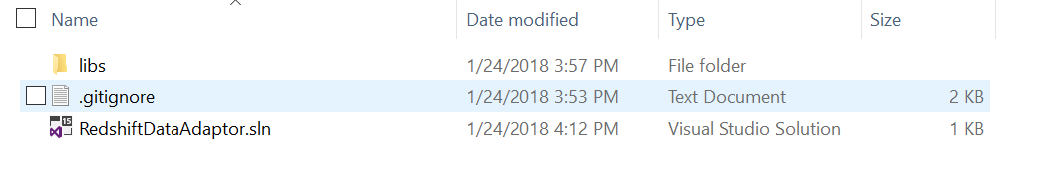

Figure : Initial project folder

Inside libs folder, create two sub-folders Dapper and Izenda to contain dependency libraries.

## Download dependency components

Download Izenda back-end package from <https://downloads.izenda.com/latest/API.zip> and extract the zip file to temp location on your machine (API folder).

From API folder that you have downloaded and extracted, browse to bin sub-folder and copy Dapper.dll to ~\Redshift\libs\Dapper (target path you have created above).

*Note that Dapper.dll above was modified for Izenda system only, other Dapper library from other source (ex: nugget package) is not supported.*

Copy below Izenda dependency libraries from API/bin to ~\Redshift\libs\Izenda:

* Izenda.BI.DataAdaptor.RDBMS.dll
* Izenda.BI.DataSourceAdapter.dll
* Izenda.BI.Framework.dll
* Izenda.BI.Logging.dll
* Izenda.BI.QueryNormalizer.Utility.dll
* Izenda.BI.RDBMS.dll
* Izenda.BI.Resource.dll
* Izenda.BI.Utility.dll

Following suggestion architecture for developing new Redshift data source adaptor, you will develop 2 components:

* Izenda.BI.QueryNormalizer.Redshift: The component provides logic to transform Izenda Raw Query to standard query for Redshift database system. It will use sequence workflow and activity pattern which are provided in library Izenda.BI.Framework.dll.
* Izenda.BI.DataAdaptor.RDBMS.Redshift: The adaptor component, contain all logic to make sure Izenda system works properly with Redshift database.

# Create Query Normalizer Component

This section describes how to create Query Normalizer Component for Redshift database, but for other database system you can follow the idea to analysis and step by step to implement corresponding component.

## General Purpose

This section shows how to create and implement a Query Normalizer component which will be used for Redshift data source adaptor. This component is developed based on sequence workflow and activity step for converting Izenda Raw Query to standard query of Redshift. Mostly, it contains definition of transformation activities which are required to normalize query for Redshift database includes:

* RedshiftEscapseTableNameActivity: This activity converts column, table and schema name escaping notation of Izenda system ( [[ and ]] ) to notation is supported by Redshift.
* RedshiftQueryNormalizerActivity: The base class defines a workflow activity. It will be inherited from IActivity<QueryNormalizerConctex>. Other activity classes will inherit this class and will be loaded automatically by sequence workflow which is provided in component Izenda.BI.Framework.dll.
* RedshiftReplaceConcatFunctionActivity: The step replaces IZENDA_CONCAT by corresponding concatenation logic in Redshift.
* RedshiftReplaceDateTruncateFunctionActivity: This will replace DATETRUNCATE by corresponding truncate method in Redshift.
* Other activity if any.

## Analysis to implement Query Normalizer Activity

Izenda normally requires minimum 3 query normalizer activities to convert Izenda Raw Query to standard query for target database system. In case of Redshift database, we also have to provide suitable query string processor to adapt that requirement.

* For column, table and schema name escaping: The activity execution will replace notation [[ and ]] in Izenda Raw Query by double quote (“). Basically, Redshift supports to use double quote (“) to handle naming identifier, it followed SQL:1999 standard.
* For IZENDA_CONATE replacement: Although Redshift support CONCAT function but it only supports two parameters in case Izenda system requires more, that is reason we must implement new logic to process concatenation multiple values, replacement for Izenda Raw function IZENDA_CONCAT.
* For DATETRUNCATE replacement: Because Redshift supports DATE_TRUNC function so it will be used to replace Izenda Raw function DATETRUNCATE.

## Create Izenda.BI.QueryNormalizer.Redshift Library

Izenda back-end run on .NET Framework 4.0 so this library must be targeted to .Net Framework 4.0.

As the naming convention is applied in Izenda system, this library also be named beginning with Izenda.BI, it is required to reserve for Sequence Workflow look up query normalizer activities automatically in library from Izenda application domain directory (usually is putted in API\bin folder).

Open RedshiftDataAdaptor.sln in Visual Studio IDE, then operate to add new project has target framework is 4.0 and project template is Class Library (.Net Framework):

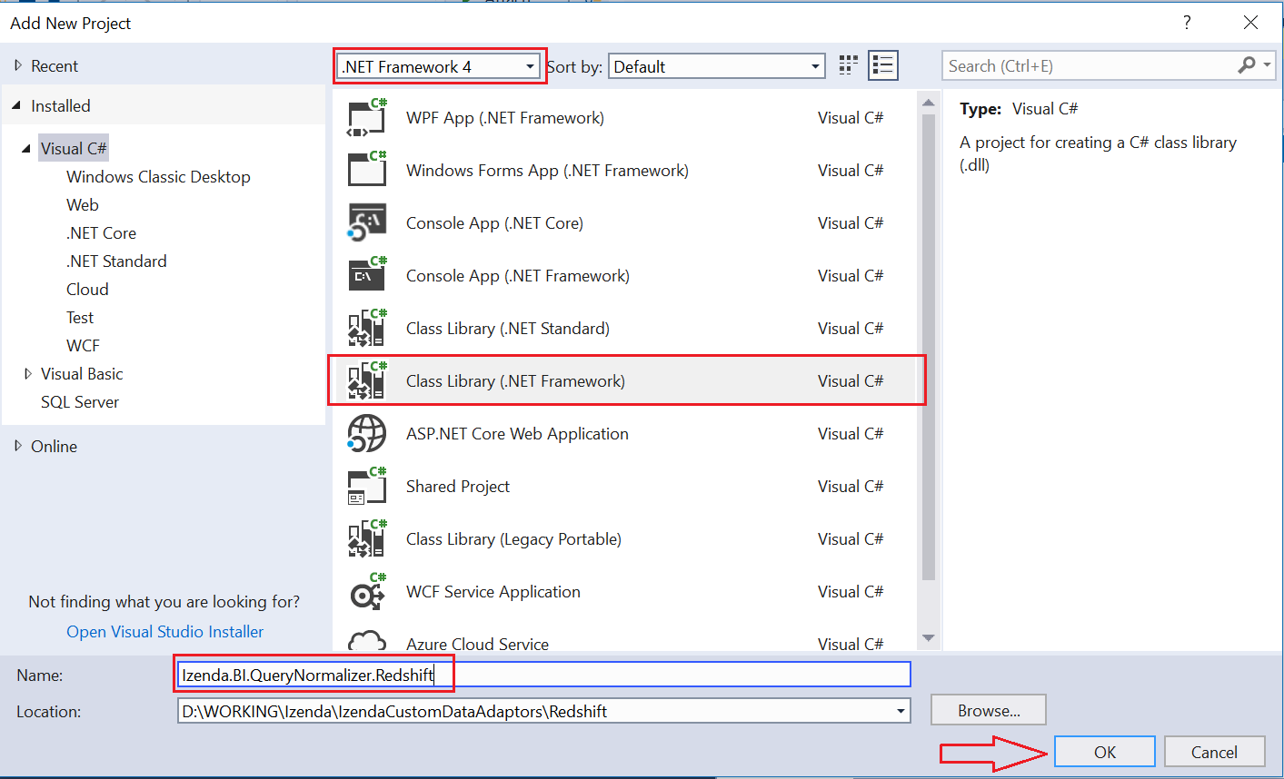

Figure : Create new Query Normalizer Library for Redshift

Click OK to create project.

After project is created completely, add project dependency to Izenda.BI.Framework.dll and Izenda.BI.QueryNormalizer.Utility.dll from folder ~Redshift\libs\Izenda:

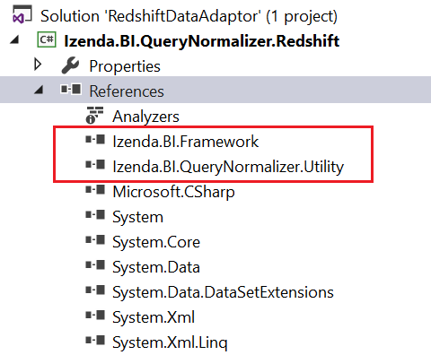

Figure : Add Izenda dependency libraries into Redshift Query Normalizer project

### Create abstracted class RedshiftQueryNormalizerActivity

This is abstract class presents for an activity, it inherits from IActivity<QueryNormalizerContext>, and will be used as parent class for every activity of Redshift Query Normalizer.

Add RedshiftQueryNormalizerActivity.cs into project then declare a class as below:

### Add class RedshiftEscapseTableNameActivity

using Izenda.BI.Framework.Components.SequenceWorkflows;

using Izenda.BI.Framework.Models.Contexts;

namespace Izenda.BI.QueryNormalizer.Redshift

{

public abstract class RedshiftQueryNormalizerActivity

: IActivity<QueryNormalizerContext>

{

public abstract int Order { get; }

public abstract void Execute(QueryNormalizerContext context);

}

}

Implementation of query normalizer activity that replaces Izenda Raw identifier for column, table and schema name as [[ and ]] by double quote (“) notation.

Add RedshiftEscapseTableNameActivity.cs file as below:

using Izenda.BI.Framework.Models.Contexts;

namespace Izenda.BI.QueryNormalizer.Redshift

{

public class RedshiftEscapseTableNameActivity : RedshiftQueryNormalizerActivity

{

/// <summary>

/// The activity order

/// </summary>

public override int Order

{

get

{

return 20;

}

}

/// <summary>

/// Execute the activity

/// </summary>

/// <param name="context">The context</param>

public override void Execute(QueryNormalizerContext context)

{

var sql = context.Query;

sql = sql.Replace("[[", @"""").Replace("]]", @"""");

context.Query = sql;

}

}

}

The Order property indicates priority of activity that will be processed by Sequence Workflow, the activity has smaller number will be processed first, otherwise bigger order will be processed later. This activity processes for naming identifier is considered as less important than other activities, so it’s Order value is 20 indicates that you are able to declare 19 remaining activities to be processed before this one.

The processing logic in this activity in implementation of Execute method is simply that replaces double open and close bracket ([[ and ]]) by double quote (“).

For example, Izenda Raw query:

SELECT [[CategoryID]] AS "categoryid_15264036_b36f_",[CategoryName]] AS "categoryname_32056250_9bdf_"

FROM [dbo]].[Categories]]

above raw query after is processed by this normalizer activity will become:

SELECT "CategoryID" AS "categoryid_15264036_b36f_","CategoryName" AS "categoryname_32056250_9bdf_"

FROM "dbo"."Categories"

### Add class RedshiftReplaceConcatFunctionActivity

Izenda Raw Query contains IZENDA_CONCAT function which absolutely is not supported in Redshift database, we have to replace that custom function by custom query logic to handle concatenate multiple values. This normalizer activity will take that responsibility.

On Izenda.BI.QueryNormalizer.Redshift project, add RedshiftReplaceConcatFunctionActivity.cs and modify class’s content like below:

using System.Text;

using Izenda.BI.Framework.Models.Contexts;

using Izenda.BI.QueryNormalizer.Utility;

namespace Izenda.BI.QueryNormalizer.Redshift

{

public class RedshiftReplaceConcatFunctionActivity

: RedshiftQueryNormalizerActivity

{

public override int Order => 10;

public override void Execute(QueryNormalizerContext context)

{

var sql = context.Query;

int index = -1;

var concat = "IZENDA_CONCAT";

index = sql.IndexOf(concat);

while (index >= 0)

{

var openIndex = sql.IndexOf("(", index);

var closeIndex = ConcatFunctionUtil.FindMatchCloseIndex(sql, openIndex + 1);

var fieldValues = sql.Substring(openIndex + 1, closeIndex - 1 - openIndex);

var fields = ConcatFunctionUtil.GetConcatParams(fieldValues);

var builder = new StringBuilder();

for (int i = 0; i < fields.Count; i++)

{

builder.Append($"CAST({fields[i].Trim()} AS TEXT)");

if (i < fields.Count - 1)

{

builder.Append(" || ");

}

}

var replacedContent = builder.ToString();

var originalContent = sql.Substring(index, closeIndex - index + 1);

sql = sql.Replace(originalContent, replacedContent);

index = sql.IndexOf(concat);

}

context.Query = sql;

}

}

}

This activity has higher priority than RedshiftEscapseTableNameActivity, so it’s Order value is 10 less than 20 of naming identifier escaping.

The concatenate processing logic is finding all parameters value of IZENDA_CONCAT function and concatenate them by concatenation operator (||) in Redshift.

### Add class RedShiftReplaceDateTruncateFunctionActivity

Izenda generates customized function DATETRUNCATE for removing time part from date value. Redshift does not support it by default, so we will implement a normalizer activity to convert that function to the function is supported in Redshift. On other hand, we will replace DATETRUCATE by DATE_TRUNC function in Redshift.

In current project, add RedShiftReplaceDateTruncateFunctionActivity.cs and modify class like below:

using Izenda.BI.Framework.Models.Contexts;

namespace Izenda.BI.QueryNormalizer.Redshift

{

public class RedShiftReplaceDateTruncateFunctionActivity

: RedshiftQueryNormalizerActivity

{

public override int Order => 12;

public override void Execute(QueryNormalizerContext context)

{

var sql = context.Query;

sql = sql.Replace(@"DATETRUNCATE", @"DATE_TRUNC");

context.Query = sql;

}

}

}

The Order of this activity is 12, that means it will be processed before RedshiftEscapseTableNameActivity but after RedshiftReplaceConcatFunctionActivity.

The replacement logic simply replaces DATETRUNCATE by DATE_TRUNC.

### Write your custom Query Normalizer Activity

If you want to write a new customized query normalizer activity to custom your query in a manner way, you can add new class that overrides abstracted class RedshiftQueryNormalizerActivity then indicates processing order as well as string processing logic in Execute method.

A customized activity is considered as extension place to customize the query will be executed by you Data Source Adaptor.

# Create Data Source Adaptor for Redshift

Basically, a Data Source Adaptor component is implementation of IDataSoruceAdaptor interface to adapt data loading and data calculation between Izenda logic layout with a database system, in this tutorial the database system is Redshift. Other RDBMS will have different approach for developing an adaptor component but you can keep logical thinking and analysis solution like this guideline while it is describing specific for Redshift.

As mentioned before, if you aim to develop new adaptor component with architecture other than based on Izenda.BI.DataSourceAdaptor.RDBMS of Izenda, you can ignore implantation description from here. But this guideline includes analysis and notice can be helpful for you when developing an adaptor in different architecture and solution approach.

Implementation of IDataSourceAdaptor is very wide abstraction scope so it will be decoupled into multiple logical dependency unit such as Connection handler, Schema Loader, data base system configuration and SQL generator includes operand command generator, function command generator and filtering generator. Those logical units are described in Overview section. Through the guideline, we are going to create RedshiftConnection, RedshiftSchemaLoader, Redshift database configuration and SQL command generator for operand, function and report filtering.

## Identify Data Provider

Each database system will provide its own data provider to woks with .Net Framework, it is library that we can use in .NET framework application. Table below describes Data Provider library for some RDBMSs:

|  |  |  |  |
| --- | --- | --- | --- |
| .No | Database | Data Provider Library | Description |
| 1 | SQL Server | System.Data.SqlClient | Namespace inside System.Data library in .NET Framework |
| 2 | Oracle | Oracle.ManagedDataAccess.dll | Oracle Data Provider for .NET, Managed Driver |
| 3 | PostgreSQL | Npgsql | ADO.NET Data Provider for PostgreSQL |
| 4 | MySQL | MySql.Data | Connector/Net, fully-managed ADO.NET driver for MySQL. |
| 5 | IBM - DB2 | IBM.Data.DB2.dll | IBM Data Server Driver |

Table : Data Provider for Relational Database System

Most RDBMS’s vendor will provide Data Provider or Driver to support connecting to a database, executing commands and retrieving result in .NET Application. To develop Izenda Data Source Adaptor for specific RDBMS, you have to identify which Data Provider will be used first.

On other hand, if your targeted RDBMS supports to work with an ODBC Driver you also use OdbcConnection which build-in in .NET Framework to communicate with your database server. We also provide an example uses OdbcConnection to build Data Source Adaptor on Github repository at <https://github.com/Izenda7Series/IzendaCustomDataAdaptors/tree/odbcdataadapter>. Note that ODBC Driver will have many limitations that leads you to issues later, be careful when choosing Data Provider.

In the case of Redshift database, we are able to use ADO.NET Data Prover for PostgreSQL or Redshift ODBC Driver. Until this document has been written, the ODBC Driver for Redshift has limitation issue when executing multiple SQL commands with multiple parameters (multiple SQL commands is split by semi colon (;)), for that reason we decide to use Data Provider for PostgreSQL in Izenda Data Source Adaptor for Redshift (Basically, Amazon Redshift was based on PostgreSQL 8.0.2). Although that, we also provides example using ODBC Driver in Redshift database, it will be described later.

## Dapper Usage

All Data Access Layer components in Izenda system use Dapper ORM Framework to process querying and executing SQL command, the adaptor for Redshift also use that library to process communicate between database and Izenda business layer.

That does not mean you are required to use Dapper for executing SQL command but IDataSourceAdaptor is depends on some type which is defined in Dapper library, that requires adaptor project always references Dapper library.

Dapper works well with almost RDBMSs but for avoiding unexpected issues happens on your data source adaptor we suggest to have fully investigation to be sure that your RDBMS Data Provider is able to work perfectly with Dapper. If they not compatibility together, you have to ignore usage of QueryMutiple method of DataSourceAdator by override GetPagingResult method and implement your customized query executing, the example for that is provided in ODBC adaptor example and will be mentioned later.

For Redshift database, we use Npgsql Data Provider and there are no issues when working with Dapper library.

## Create new Adaptor Project

Like SQL Query Normalizer component, the adaptor component also has to be targeted to .NET Framework 4.0 and follow naming convention for library in entire Izenda system.

Open RedshiftDataAdaptor.sln in Visual Studio IDE, Lets add new project Izenda.BI.DataAdaptor.RDBMS.Redshift like below:

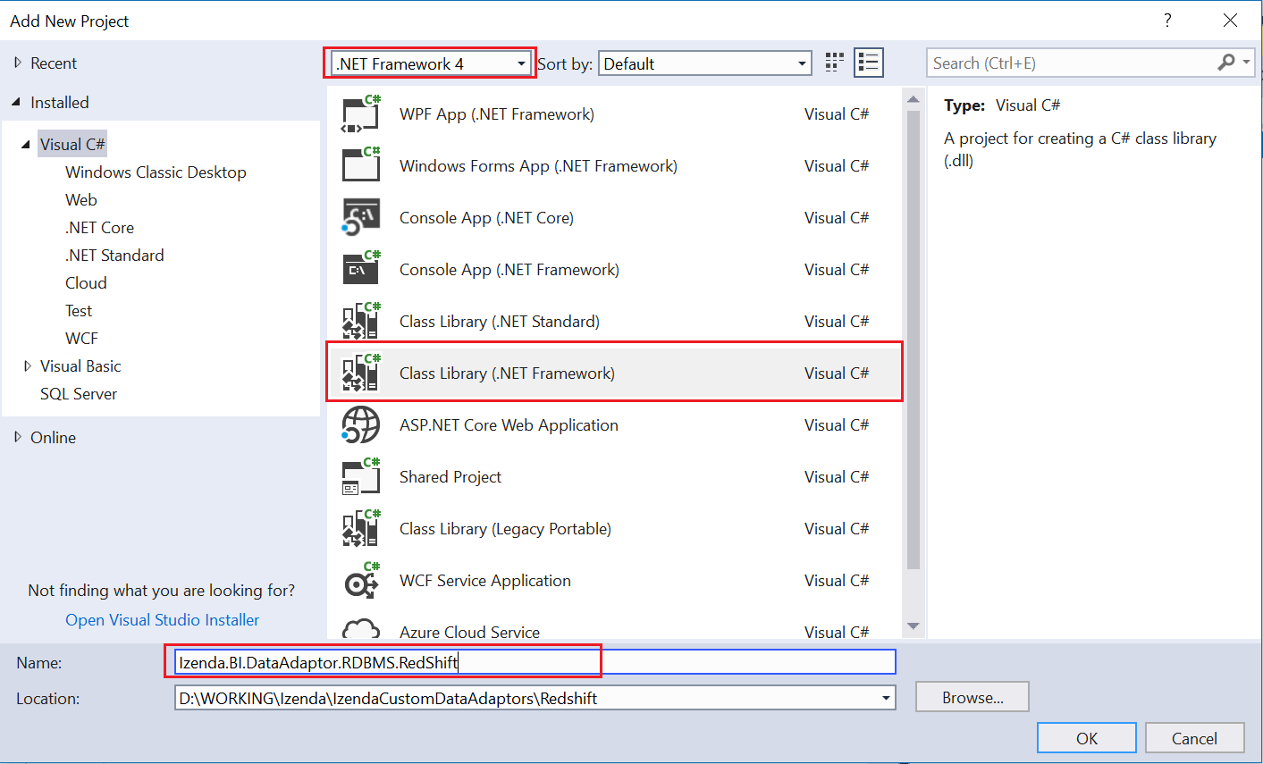

Figure : Create new Redshift Data Source Adaptor

Click OK button to create empty project.

## Add Project Dependency

Add library dependency from ~\Redshift\libs\Izenda and ~\Redshift\libs\Dapper:

* Izenda.BI.DataAdaptor.RDBMS.dll
* Izenda.BI.DataSourceAdapter.dll
* Izenda.BI.Framework.dll
* Izenda.BI.Logging.dll
* Izenda.BI.RDBMS.dll
* Izenda.BI.Resource.dll

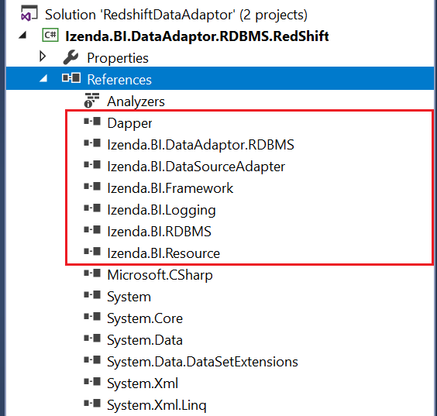

Figure : Izenda library dependency in adaptor component

Add project dependency Izenda.BI.QueryNormalizer.Redshift:

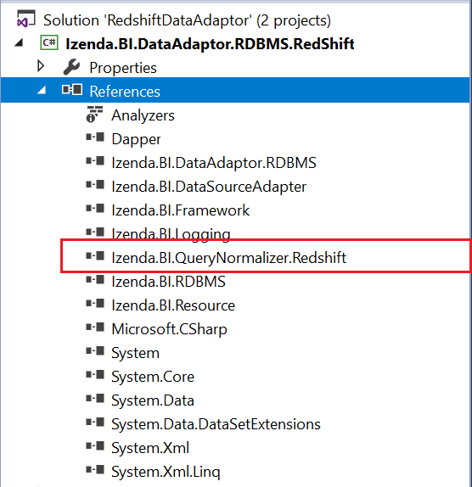

Figure : Add Query Normalizer project dependency

Add ADO.NET Data Provider for PostgreSQL from nugget package by open Tools/Nuget Package Manager/Package Manager Console and type PM> Install-Package Npgsql -Version 2.2.7

Note that, we only need Npgsql version 2.2.7 works on .NET Framework 4.0, the latest version is higher but it works for newer .NET version.

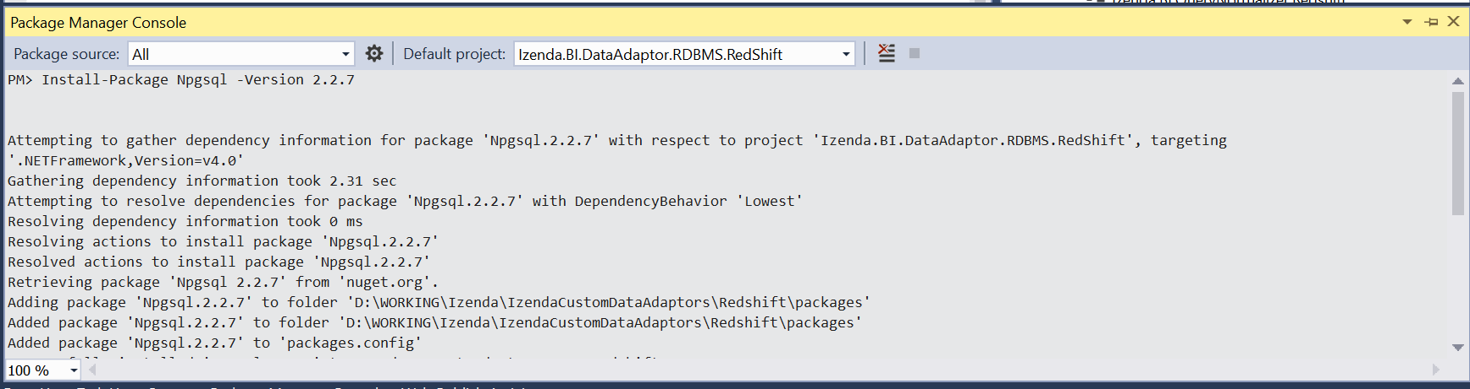

Figure : Using Nuget Package Manager Console to add dependency to Npgsql 2.2.7

The completed dependency of adaptor project will like below:

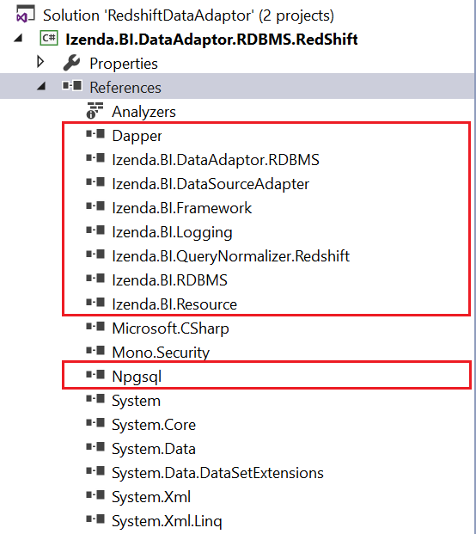

Figure : Library dependency of adaptor project

## Configure Data Types and Build-in Functions

### Data Types

Create folder Constants in project then add the class RedShiftSupportDataType.cs, modify that class to inherit from DatabaseSupportDataType in Izenda.BI.DataAdaptor.RDBMS.Constants.

Adding the mapping between data type of Redshift, Izenda and .NET type:

Date Time Data Types:

private void RegisterDateTime()

{

AddDatabaseDataType("date", IzendaDataType.DatetimeType, true, "System.DateTime", true/*default mapping*/);

// timestamp is alias for [timestamp with time zone]

AddDatabaseDataType("timestamp", IzendaDataType.DatetimeType, true, "System.DateTime");

AddDatabaseDataType("timestamp with time zone", IzendaDataType.DatetimeType, true, "System.DateTime");

// timestamptz is alias for [timestamp without time zone]

AddDatabaseDataType("timestamptz", IzendaDataType.DatetimeType, true, "System.DateTime");

AddDatabaseDataType("timestamp without time zone", IzendaDataType.DatetimeType, true, "System.DateTime");

}

Numeric Data Types:

private void RegisterNumeric()

{

AddDatabaseDataType("numeric", IzendaDataType.NumericType, true, "System.Decimal", true /*default mapping*/);

// integer

AddDatabaseDataType("smallint", IzendaDataType.NumericType, true, "System.Int16");

AddDatabaseDataType("int2", IzendaDataType.NumericType, true, "System.Int16");

AddDatabaseDataType("integer", IzendaDataType.NumericType, true, "System.Int32");

AddDatabaseDataType("int", IzendaDataType.NumericType, true, "System.Int32");

AddDatabaseDataType("int4", IzendaDataType.NumericType, true, "System.Int32");

AddDatabaseDataType("int8", IzendaDataType.NumericType, true, "System.Int64");

AddDatabaseDataType("bigint", IzendaDataType.NumericType, true, "System.Int64");

// floating point number

AddDatabaseDataType("real", IzendaDataType.NumericType, true, "System.Single");

AddDatabaseDataType("float4", IzendaDataType.NumericType, true, "System.Single");

AddDatabaseDataType("float", IzendaDataType.NumericType, true, "System.Double");

AddDatabaseDataType("float8", IzendaDataType.NumericType, true, "System.Double");

AddDatabaseDataType("double precision", IzendaDataType.NumericType, true, "System.Double");

AddDatabaseDataType("decimal", IzendaDataType.NumericType, true, "System.Decimal");

}

Boolean Data Types:

private void RegisterBoolean()

{

// bool is alias for boolean

AddDatabaseDataType("bool", IzendaDataType.BooleanType, true, "System.Boolean");

AddDatabaseDataType("boolean", IzendaDataType.BooleanType, true, "System.Boolean", true/*default mapping*/);

}

Text Data Types:

private void RegisterText()

{

// 4k range

AddDatabaseDataType("char", IzendaDataType.TextType, true, "System.String");

AddDatabaseDataType("character", IzendaDataType.TextType, true, "System.String");

AddDatabaseDataType("nchar", IzendaDataType.TextType, true, "System.String");

AddDatabaseDataType("national character", IzendaDataType.TextType, true, "System.String");

// 64k range

AddDatabaseDataType("varchar", IzendaDataType.TextType, true, "System.String", true/*default mapping*/);

AddDatabaseDataType("character varying", IzendaDataType.TextType, true, "System.String");

AddDatabaseDataType("nvarchar", IzendaDataType.TextType, true, "System.String");

AddDatabaseDataType("national character varying", IzendaDataType.TextType, true, "System.String");

// 265 bytes

AddDatabaseDataType("bpchar", IzendaDataType.TextType, true, "System.String");

AddDatabaseDataType("text", IzendaDataType.TextType, true, "System.String");

}

Combine above data types mapping to register in constructor method:

public class RedShiftSupportDataType : DatabaseSupportDataType

{

public RedShiftSupportDataType()

{

RegisterNumeric();

RegisterDateTime();

RegisterBoolean();

RegisterText();

}

…

}

The full implementation of RedhisfhtSupportDataType class at [Provide Link].

### Database Functions

The table #2 list all functions that are used in Izenda system but some of functions maybe is not available on your targeted database system or function naming can be different, in that case you have to provide configuration to indicate new adapter component use new name or syntax of corresponding function.

Comparing in Redshift database, we see the DatePart and IsNull property in DatabaseFunction class have to be overridden to provide in new name and new syntax. The DataPart must be date_part and the IsNull function will be replaced by nvl function.

In Constants folder, add class RedshiftDatabaseFunction.cs and override property DatePart and IsNull as below:

using Izenda.BI.DataAdaptor.RDBMS.Constants;

namespace Izenda.BI.DataAdaptor.RDBMS.RedShift.Constants

{

public class RedshiftDatabaseFunction : DatabaseFunction

{

public override string DatePart

{

get

{

return "date_part";

}

}

public override string IsNull

{

get

{

return "nvl";

}

}

}

}

Logically, this configuration will be used to generate corresponding SQL syntax for expression command will be described in later section.

### Database Function Format

According the function formats listed in table #3, Izenda system has predefined function formats which are using to call database function. If on your database system, the function has different format that will require we have to configure that changes to make Izenda system understands function format syntax on your database system.

Most of formats in DatabaseFunctionFormat server for date time format and filtering date time value on Izenda report, those configurations take affected when we provide filtering command generator on adaptor component, combine with feature that data adaptor loads filtering command generator by .NET refection, all of them will be overridden so that makes format configuration affect automatically.

Investigation and comparing the function format syntax in based adaptor and Redshift, the format property CheckBlankFormatText, CheckNotBlankFormat and CheckNotBlankFormatText will be override to provide new syntax.

In Constants folder, Add RedshiftDatabaseFunctionFormat.cs and implement overriding like below:

using Izenda.BI.DataAdaptor.RDBMS.Constants;

namespace Izenda.BI.DataAdaptor.RDBMS.RedShift.Constants

{

public class RedshiftDatabaseFunctionFormat : DatabaseFunctionFormat

{

public override string CheckBlankFormatText

{

get

{

return @"[[{0}]] = ''";

}

}

public override string CheckNotBlankFormat

{

get

{

return "([[{0}]] IS NULL OR [[{0}]] <> '')";

}

}

public override string CheckNotBlankFormatText

{

get

{

return "([[{0}]] IS NULL OR [[{0}]] <> '')";

}

}

}

}

Those properties are used in JoinOperatorCommandGenerator, so to make this configuration effect that operator command generator have to be overridden and it will be described detail in later section.

### Database Constants

Because of datepart and timepart in Redshift database are supported similar with default configuration in DatabaseConstants class in Izenda.BI.Framework.Constants namespace, so we no need to override to change the configuration for this database.

The CONVERT method also work well to convert date time value in Redshift then.

## Implement connection handler class

This class manages connection to the Redshift database over ADO.NET Data Provider for PostgreSQL (Npgsql library), and take responsibility for retrieving information about connection.

ReshiftConnection class will be used to decouple abstraction from implementation of IDataSourceAdaptor interface so that it can vary independently on connection functionality.

Add RedshiftConnection.cs and modify to inherits from IConnection in Izenda.BI.Framwork.

The table below describes functionality for each method inside IConnection interface:

|  |  |  |
| --- | --- | --- |
| # | Method | Description |
| 1 | GetDatabaseName | Get the name of database which is connected by current connection string |
| 2 | GetDatabaseServer | Return the name of database server which is connected by current connection string |
| 3 | GetUserName | Get user name in user credential info for connecting to the database |
| 4 | OpenConnection | Use Data Provider to open new connection for current connection string |
| 5 | TestConnection | Actually open the connection and verify whether connection is connected OK or not |

Figure : Describe method of IConnection interface

The completed implementation of RedshiftConnection class as below:

using Izenda.BI.Framework;

using System;

using System.Collections.Generic;

using Izenda.BI.Framework.Models;

using System.Data;

using Izenda.BI.Framework.Constants;

using Npgsql;

namespace Izenda.BI.DataAdaptor.RDBMS.RedShift

{

public class RedShiftConnection : IConnection

{

public string GetDatabaseName(string connectionString)

{

var builder = new NpgsqlConnectionStringBuilder(connectionString);

return builder.Database;

}

public string GetDatabaseServer(string connectionString)

{

var builder = new NpgsqlConnectionStringBuilder(connectionString);

return builder.Host;

}

public string GetUserName(string connectionString)

{

var builder = new NpgsqlConnectionStringBuilder(connectionString);

return builder.UserName;

}

public IDbConnection OpenConnection(string connectionString)

{

var connection = new NpgsqlConnection(connectionString);

connection.Open();

return connection;

}

public ConnectionStatus TestConnection(Guid serverType, string connectionString)

{

var result = new ConnectionStatus

{

Status = ConnectDBStatus.Success,

ConnectionString = connectionString

};

try

{

var databaseName = GetDatabaseName(connectionString);

if (string.IsNullOrEmpty(databaseName))

{

result.Status = ConnectDBStatus.DatabaseNotValid;

return result;

}

using (var connection = OpenConnection(connectionString))

{

result.Status = ConnectDBStatus.Success;

return result;

}

}

catch (NpgsqlException ex)

{

var invalidServerMessage = new List<string> { "08000", "08003", "08006", "08001", "08004", "08007", "08P01" }; //These numbers is status code return by database relate to server name or network issue.

var invalidDatabase = "3D000"; //Error code return when database is not valid

var loginFail = new List<string> { "28000", "28P01" }; //Error code return when cannot loggin database

if (invalidServerMessage.Contains(ex.Code))

{

result.Status = ConnectDBStatus.ServerNotValid;

}

else if (ex.Code == invalidDatabase)

{

result.Status = ConnectDBStatus.DatabaseNotValid;

}

else if (loginFail.Contains(ex.Code))

{

result.Status = ConnectDBStatus.LoginFail;

}

else

{

result.Status = ConnectDBStatus.Fail;

}

}

catch

{

result.Status = ConnectDBStatus.Fail;

}

return result;

}

}

}

## Implement schema loader class

The class takes responsibility for discovering database schema structure as schema name, table, view, column, function and store procedure parameter, relationship then convert to Izenda abstraction entry such as DB Source, Query Source Category, Query Source, Query Source Field, Query Source Parameter and Relationship.

Schema loader class will be inherited from ISchemaLoader interface in Izenda.BI.DataAdaptor.RDBMS library. It will be composite component inside implementation of IDataSourceAdaptor, the based data source adaptor class DataSourceAdaptor in Izenda.BI.DataAdaptor.RDBMS component as well as implementation of specific database system. By split schema loading logic into ISchemaLoader, we can re-use many coding from DataSourceAdaptor then reduce much effort to develop new adaptor component.

Schema loader is important logic and requires carefully analysis and develop, it explores your data source schema and structure then transform to Izenda logic concept so if that progress is not perform correctly it can make Izenda system works incorrectly with many multiple major issues.

Each RDBMS stores database structure in different manner, to implement schema loader you have to study and have fully understand about it. With Amazon Redshift the collection of existing schema is stored in *pg_namespace* table, all table and view are stored in *information_schema.tables* and distinct between table and view by *table_type* column value *BASE TABLE* and *VIEW*, all the columns of table and view are stored in *information_schema.columns*, the information of function is stored in *pg_proc* and *information_schema.routine*, Redshift does not support store procedure by default. For parameters Redshift store it in table *information_schema.parameters*. About relationship information, they are stored in *information_schema.key_column_usage*, *information_schema.constraint_column_usage*, *information_schema.referential_constraints* and *pg_constrain* as well. We will use that tables to explore database structure in Redshift for schema loader implementation.

### ISchemaLoader interface and implementation

This section will describe detail functionality of methods in schema loader interface and how to implement it in inherited class.

For Redshift database, schema loader is named as RedshiftSchemaLoader, add RedshiftSchemaLoader.cs into project and modify it inherit from ISchemaLoader interface.

using Izenda.BI.DataAdaptor.SQL.SchemaLoader;

using System;

using System.Collections.Generic;

using Izenda.BI.Framework.Models;

using Izenda.BI.Logging;

namespace Izenda.BI.DataAdaptor.RDBMS.RedShift

{

public class RedshiftSchemaLoader : ISchemaLoader

{

public List<QuerySourceParameter> GetQuerySourceParameters(string connectionString)

{

throw new NotImplementedException();

}

public List<QuerySourceParameter> GetQuerySourceParameters(string connectionString, string specificSchema, string specificName)

{

throw new NotImplementedException();

}

public List<QuerySourceField> LoadCustomQuerySourceFields(string connectionString, string customQueryDefinition)

{

throw new NotImplementedException();

}

public List<QuerySourceField> LoadFields(string connectionString, string type, string categoryName, string querySourceName, bool rollbackSP, List<QuerySourceParameter> parameters = null, bool ignoreError = true, int commandTimeout = 500, ILog log = null)

{

throw new NotImplementedException();

}

public List<QuerySourceField> LoadQuerySourceFields(string connectionString)

{

throw new NotImplementedException();

}

public List<Relationship> LoadRelationships(string connectionString, List<string> schemas = null)

{

throw new NotImplementedException();

}

public DBSource LoadSchema(string connectionString)

{

throw new NotImplementedException();

}

}

}

### GetQuerySourceParameters(string)

List<QuerySourceParameter> GetQuerySourceParameters(string connectionString);

Get all parameters of all functions and store procedures in database in connection string.

Parameters:

* connectionString: The connection string to data source.

The implementation for this method is call to other overload of GetQuerySourceParameters method.

public List<QuerySourceParameter> GetQuerySourceParameters(string connectionString)

{

return GetQuerySourceParameters(connectionString, string.Empty, string.Empty);

}

### GetQuerySourceParameters(string, string, string)

Get all parameters of specific function or store procedure in specific schema.

public List<QuerySourceParameter> GetQuerySourceParameters(string connectionString, string specificSchema, string specificName)

Parameters:

* connectionString: the connection string to data source.
* specificSchema: The schema name to filter parameter list.
* specificName: The name of function or store procedure to get all parameters.

Implementation:

For Redshift database, all parameters are stored in *information_schema.paramters*, in this method we query parameter info from that table then convert to Izenda Query Source Parameter.

public List<QuerySourceParameter> GetQuerySourceParameters(string connectionString, string specificSchema, string specificName)

{

var dataTypeAdaptor = new RedshiftSupportDataType();

using (var conn = new NpgsqlConnection(connectionString))

{

var sql = @"SELECT specific_schema, specific_name, parameter_mode, is_result

,parameter_name, data_type, ordinal_position

FROM information_schema.parameters";

if (!string.IsNullOrEmpty(specificSchema) && !string.IsNullOrEmpty(specificName))

{

sql += " WHERE specific_schema = @SPECIFIC_SCHEMA AND specific_name=@SPECIFIC_NAME ";

}

var parametes =

conn.Query<dynamic>(sql, new { SPECIFIC_SCHEMA = specificSchema, SPECIFIC_NAME = specificName })

.Select(s => new QuerySourceParameter

{

Name = s.PARAMETER_NAME,

QuerySourceName = s.SPECIFIC_NAME,

Category = s.SPECIFIC_SCHEMA,

DataType = s.DATA_TYPE,

IzendaDataType = dataTypeAdaptor.GetIzendaDataType(s.DATA_TYPE),

InputMode = s.PARAMETER_MODE.Equals("IN", StringComparison.OrdinalIgnoreCase),

Result = s.IS_RESULT.Equals("YES", StringComparison.OrdinalIgnoreCase),

Position = s.ORDINAL_POSITION,

Value = DBNull.Value,

AllowDistinct = dataTypeAdaptor.GetAllowDistinct(s.DATA_TYPE)

}).ToList();

return parametes;

}

}

On other RDBMS, you have to find out how it manages function and store procedure parameters and provide corresponding query to get out parameter information.

### LoadCustomQuerySourceFields(string, string)

List<QuerySourceField> LoadCustomQuerySourceFields(string connectionString, string customQueryDefinition);

Get all columns from custom query.

Parameters:

* connectionString: The connection string to the data source.
* customQueryDefinition: The custom query.

Implementation: Execute custom query and get column list from data reader result then convert to Izenda Query Source Field.

public List<QuerySourceField> LoadCustomQuerySourceFields(string connectionString, string customQueryDefinition

{

var result = new List<QuerySourceField>();

var dataTypeAdaptor = new RedShiftSupportDataType();

using (var conn = new NpgsqlConnection(connectionString))

{

conn.Open();

NpgsqlCommand command = new NpgsqlCommand(customQueryDefinition, conn);

command.CommandType = CommandType.Text;

NpgsqlDataReader reader = command.ExecuteReader(CommandBehavior.SchemaOnly);

DataTable schema = reader.GetSchemaTable();

for (int i = 0; i < schema.Rows.Count; i++)

{

string dataType = reader.GetDataTypeName(i);

result.Add(

new QuerySourceField

{

Name = schema.Rows[i]["ColumnName"].ToString() ?? "",

DataType = dataType,

IzendaDataType = dataTypeAdaptor.GetIzendaDataType(dataType),

AllowDistinct = dataTypeAdaptor.GetAllowDistinct(dataType),

ExtendedProperties = "",

Position = Convert.ToInt32(schema.Rows[0]["ColumnOrdinal"].ToString())

}

);

}

}

return result;

}

### LoadQuerySourceField(string)

List<QuerySourceField> LoadQuerySourceFields(string connectionString);

Get all columns of all tables and views in database.

Parameters:

* connectionString: The connection string to the data source.

Implementation: Call the method LoadFieldFromTable which is defined in section of LoadField method.

public List<QuerySourceField> LoadQuerySourceFields(string connectionString)

{

return LoadFieldsFromTable(connectionString);

}

### LoadSchema(string)

DBSource LoadSchema(string connectionString);

The method loads entire data source structure includes schema, table, view, store procedure and functions then transform to Izenda abstraction concept. All database schema structure will be stored into DBSource object, and logically that object will be stored into Izenda system database when a connection string is saved.

Parameters:

* connectionString: The connection string to the data source.

Implementation of this method follows the idea that it gets all database schemas as list of Query Source Category, in each Query Source Category (schema) it gets all tables, views, store procedures and functions as list of Query Source which is belong the current schema.

Implementation in RedshiftSchemaLoader:

Get all schema: This gets all schemas of database in current connection from *pg_namespace* tables and exclude built-in schemas.

protected IList<QuerySourceCategory> GetSchemas(IDbConnection conn, string excludeSchemas)

{

string sql = string.Format(@"SELECT nspname FROM pg_namespace WHERE nspname NOT IN({0})", excludeSchemas);

var querySourceCategories = conn.Query<dynamic>(sql)

.Select(s => new QuerySourceCategory { Name = s.nspname })

.ToList();

return querySourceCategories;

}

Get all tables and views: This get all tables or views from *information_schema.tables* for each schema of database in current connection.

protected IList<QuerySource> GetTables(IDbConnection conn, string schemaName, string tableType)

{

string sql = @" SELECT table_name,table_type

FROM information_schema.tables

WHERE table_schema=@schema AND table_type=@type";

var sqlQuerySourceType = "UNKNOW";

if (SQL_TYPE_TABLE.Equals(tableType, StringComparison.OrdinalIgnoreCase))

{

sqlQuerySourceType = SQLQuerySourceType.Table;

}

else if (SQL_TYPE_VIEW.Equals(tableType, StringComparison.OrdinalIgnoreCase))

{

sqlQuerySourceType = SQLQuerySourceType.View;

}

var querySources = conn.Query<dynamic>(sql, new { schema = schemaName, type = tableType })

.Select(s => new QuerySource

{

Name = s.table_name,

Type = sqlQuerySourceType

})

.ToList();

return querySources;

}

Get all functions: This get all functions from *information_schema.routines* of each schema of database in current connection.

protected IList<QuerySource> GetFunctions(IDbConnection conn, string schemaName)

{

string sql = string.Format(LOAD_SCHEMA_FUNCTION, 0);

var querySources = conn.Query<dynamic>(sql, new { schema = schemaName, type = SQL_TYPE_FUNCTION });

var result = new List<dynamic>();

foreach (var querySource in querySources)

{

result.Add(querySource);

}

return result.Select(s => new QuerySource

{

Name = s.routine_name,

Type = SQLQuerySourceType.Function

}).GroupBy(x => x.Name).Select(x => x.First()).ToList();

}

Get all store procedure: This get all store procedures from *information_schema.routines* of each schema of database in current connection. Although Redshift does not support procedure but this is used to demonstrate store procedure loading which has similar logic on other RDBMS.

protected IList<QuerySource> GetProcedures(IDbConnection conn, string schemaName)

{

string sql = string.Format(LOAD_SCHEMA_FUNCTION, 1);

var querySources = conn.Query<dynamic>(sql, new { schema = schemaName, type = SQL_TYPE_FUNCTION });

var result = querySources.Select(s => new QuerySource

{

Name = s.routine_name,

Type = SQLQuerySourceType.Procedure

}).GroupBy(x => x.Name);

if (result.Where(x => x.Count() > 1).Count() > 0)

{

var modelErrors = new ModelErrors();

modelErrors.AddError(string.Empty, Messages.DuplicateFunctionName);

throw new IzendaModelException(modelErrors);

}

return result.Select(x => x.First()).ToList();

}

Combine getting schemas, tables, views, functions and store procedures above we have the full implementation of LoadSchema method in RedshiftSchemaLoader class:

public DBSource LoadSchema(string connectionString)

{

using (var conn = new NpgsqlConnection(connectionString))

{

conn.Open();

var querySourceCategories = GetSchemas(conn, EXCLUDE_SCHEMAS);

foreach (var category in querySourceCategories)

{

category.QuerySources = new List<QuerySource>();

// Load Tables

category.QuerySources.AddRange(GetTables(conn, category.Name, SQL_TYPE_TABLE));

// Load Views

category.QuerySources.AddRange(GetTables(conn, category.Name, SQL_TYPE_VIEW));

// Load Functions

category.QuerySources.AddRange(GetFunctions(conn, category.Name));

// Load store procedure

category.QuerySources.AddRange(GetProcedures(conn, category.Name));

// Sort by name

category.QuerySources = category.QuerySources.OrderBy(s => s.Name).ToList();

}

return new DBSource

{

QuerySources = querySourceCategories.ToList()

};

}

}

### LoadFields(string, string, string, string, bool, List<QuerySourceParamter>, bool, int, ILog)

This method will load all columns (query source fields) of a table, view or store procedure in specific schema of current connection and map them to Query Source Field objects. In case of loading query source field for store procedure it requires to execute that procedure, that case makes the last 5 parameters to be used.

This method is exactly same with similar one in IDataSourceAdaptor interface. It is declared here to provide better design for breaking dependency as well as serving single responsibility in implementation, it will be used in multiple locations on Izenda Business Layer and based class DataSourceAdaptor in Izenda.BI.DataAdaptor.RDBMS component.

List<QuerySourceField> LoadFields(string connectionString, string type, string categoryName, string querySourceName, bool rollbackSP, List<QuerySourceParameter> parameters = null, bool ignoreError = true, int commandTimeout = 500, ILog log = null);

Parameters:

* connectionString: The connection string to the data source
* type: The SQL Query Source Type and the value can be Table, View or Store Procedure
* categoryName: The schema name of table, view or store procedure
* querySroucename: The either table name, view name or store procedure name.
* rollbackSP: Is using when loading fields for store procedure, if true it requests new transaction to rollback command to execute store procedure, that’s because to get all the fields of store procedure it requires to call procedure then getting the field set from result, and some procedure will change data when it is executed so it requires to rollback that changed to make sure the database will not be affected. This parameter is only applied when loading field for store procedure.
* List<QuerySourceParameter>: The list of parameter for executing store procedure to get field set from result. This parameter is only applied when load field for store procedure.
* ignoreError: Indicate that system always continue to run although there is error when executing store procedure. This parameter is only applied when load field for store procedure.
* commandTimeout: The time out for executing store procedure. This parameter is only applied when loading field for store procedure.
* ILog: The Izenda logger instance to log tracking when loading field. You can use this log instance to log out your tracking information and that info will be appended into izenda log file.

Implementation in RedshiftSchemaLoader:

Get all columns of table or view: This implementation will get all columns of a table or view from *information_schema.columns* then convert to Izenda Query Source Field object.

private List<QuerySourceField> LoadFieldsFromTable(string connectionString, string schemaName = "", string tableName = "")

{

var result = new List<QuerySourceField>();

var dataTypeAdaptor = new RedshiftSupportDataType();

string sql = @"SELECT DISTINCT c.column_name, c.data_type, c.ordinal_position, c.table_schema, c.table_name

FROM information_schema.Columns c";

if (!string.IsNullOrWhiteSpace(tableName) && !string.IsNullOrWhiteSpace(schemaName))

{

sql += @" WHERE c.table_schema = @TableSchema AND c.table_name = @TableName ";

}

using (var conn = new NpgsqlConnection(connectionString))

{

conn.Open();

result = conn.Query<dynamic>(sql, new { TableSchema = schemaName, TableName = tableName })

.Select(s => new QuerySourceField

{

Name = s.column_name,

CategoryName = s.table_schema ?? "",

QuerySourceName = s.table_name ?? "",

DataType = s.data_type,

IzendaDataType = dataTypeAdaptor.GetIzendaDataType(s.data_type),

AllowDistinct = dataTypeAdaptor.GetAllowDistinct(s.data_type),

Position = s.ordinal_position,

ExtendedProperties = ""

})

.Where(x => !string.IsNullOrEmpty(x.IzendaDataType))

.ToList();

}

return result;

}

Get all columns in store procedure: This implementation is not necessary for Redshift. In other RDBMS, we need to execute store procedure then get the columns from schema of data reader result, the implementation detail for this will be described in section how to create ODBC Data Adaptor.

### LoadRelationship(string, List<string>)

List<Relationship> LoadRelationships(string connectionString, List<string> schemas = null);

Load all relationships of database in connection string.

Parameters:

* connectionString: The connection string to data source.
* schemas: The list of schema name to filter constraints.

Implementation:

Combine information from *information_schema.key_coulumn_usage*, *information_schema.constraint_column_usage* and *information_schema.referenctial_constraints* we get all necessary information about relationship then convert to Relationship object.

public List<Relationship> LoadRelationships(string connectionString, List<string> schemas = null)

{

using (var conn = new NpgsqlConnection(connectionString))

{

string sql = @"SELECT kcu.constraint_name as fk_name,

kcu.constraint_schema as jionschema,

kcu.table_name as jiontable,

kcu.column_name as jioncolumn,

ccu.constraint_schema as foreignschema,

ccu.table_name as foreigntable,

ccu.column_name as foreigncolumn

FROM information_schema.key_column_usage as kcu

INNER JOIN information_schema.constraint_column_usage as ccu on ccu.constraint_name = kcu.constraint_name

INNER JOIN information_schema.referential_constraints as rc on rc.constraint_name = kcu.constraint_name

if (schemas != null && schemas.Count() > 0)

{

sql += $" WHERE kcu.constraint_schema IN ({schemas.Aggregate((s1, s2) => $"'{s1}', '{s2}'")})";

}

var relationships = conn.Query<dynamic>(sql)

.Select(r => new Relationship

{

JoinQuerySourceName = r.jionschema + '.' + r.jiontable,

ForeignQuerySourceName = r.foreignschema + '.' + r.foreigntable,

JoinFieldName = r.jioncolumn,

ForeignFieldName = r.foreigncolumn

})

.ToList();

return relationships;

}

}

## Implement Data Source Adaptor class

### Declare adaptor class and exported configuration

In adaptor project add RedshiftDataAdaptor.cs and modify the class inherits from DataSourceAdaptor in Izenda.BI.DataAdaptor.RDBMS namespace.

Logically, Izenda system automatically loads all Data Source Adaptor from libraries which are available in application domain directory. To register the implementation of IDataSourceAdator interface is adaptor lets declare export contract and metadata on top of adaptor class like below:

[Export(typeof(IDataSourceAdaptor))]

[ExportMetadata("ServerType", "E285BFD1-F8D5-4BEB-A345-B3D2EF5A3DE8" + "|AWSRS|[AWSRS] Redshift")]

public class RedshiftDataSourceAdaptor : DataSourceAdaptor

Note that Export and ExportMetadata keyword only are available when you add reference System.ComponentModel.Composition into adaptor project.

Izenda uses MEF to handle exporting an adaptor, the type of interface IDataSourceAdator is provided as exported contract and the metadata ServerType is provided to distinguish between multiple existing data adaptor available in application domain directory. The metadata basically contains two part, first part E285BFD1-F8D5-4BEB-A345-B3D2EF5A3DE8 is GUID identifier of adaptor and second part "|AWSRS|[AWSRS] Redshift is display name of adaptor.

The first implementation of RedshiftDataAdaptor class looks like below:

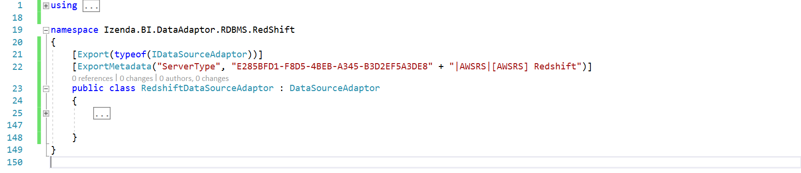

Figure : The first figure of implementation in RedshiftDataAdaptor class

You no need to implement all methods in IDataSourceAdaptor interface, we will re-use source code implementation from DataSourceAdaptor - the based adaptor class for any RDBMS. Sub sections after this will describes the way to override some methods form DataSourceAdapter class to provide necessary implementation to make data adaptor work properly with Izenda business layer. Most of other RDBMS also is able to work when applying the list of overriding method in other next sections.

To avoid confusion when following sample code, the adaptor will use below namespaces at all:

* Dapper
* Izenda.BI.DataAdaptor.RDBMS.CommandGenerators
* Izenda.BI.DataAdaptor.SQL.SchemaLoader
* Izenda.BI.Framework
* Izenda.BI.Framework.Components.SequenceWorkflows
* Izenda.BI.Framework.Models.Contexts
* Izenda.BI.RedShift
* Izenda.BI.QueryNormalizer.RedShift
* System.Collections.Generic
* System.ComponentModel.Composition
* Izenda.BI.Framework.Models
* Izenda.BI.DataAdaptor.RDBMS.RedShift.Constants
* Izenda.BI.Framework.Constants
* Izenda.BI.DataAdaptor.RDBMS.RedShift.CommandGenerators
* Npgsql
* Izenda.BI.Framework.Exceptions
* Izenda.BI.Resource
* System
* System.Text.RegularExpressions
* System.Linq

From that namespace you are able to figure out which dependency components and technology will be used to implement the Redshift data adaptor.

### Override SchemaLoader and Connection Property

Override SchemaLoader and Connection property, return corresponding RedshiftSchemaLoader and RedshiftConnection we have created above.

public override ISchemaLoader SchemaLoader => new RedshiftSchemaLoader();

public override IConnection Connection => new RedshiftConnection();

### Override NormalizeQuery(string) Method

This method is used to normalize query to standard query of Redshift, basically it will convert Izenda Raw Query to standard query syntax of Redshift database.

Declare sequence workflow property as one-time initialization property:

ISequenceWorkflow<RedshiftQueryNormalizerActivity, QueryNormalizerContext> queryNormalizer;

protected ISequenceWorkflow<RedshiftQueryNormalizerActivity, QueryNormalizerContext> QueryNormalizer

{

get

{

if (queryNormalizer == null)

{

queryNormalizer = new SequenceWorkflow<RedshiftQueryNormalizerActivity, QueryNormalizerContext>();

}

return queryNormalizer;

}

}

Override method NormalizeQuery(string) as below:

protected override string NormalizeQuery(string query)

{

var normalizerContext = new QueryNormalizerContext { Query = query };

QueryNormalizer.Execute(normalizerContext);

return normalizerContext.Query;

}

### Override GetConnectionStringWithServerAndDatabaseName(string) Method

This method simply returns concatenation of database server and database name in specific format.

public override string GetConnectionStringWithServerAndDatabaseName(string connectionString)

{

var builder = new NpgsqlConnectionStringBuilder(connectionString);

if (builder.IntegratedSecurity)

{

return connectionString;

}

return string.Format("Server={0}; Database={1};", builder.Host, builder.Database);

}

### Override GetFirstValueInFilteredQuery Property

Property provides SQL syntax format to get first value in data source from database, first holder reserves for field list (columns) and second one is reserved for query source name (table or view).

public override string GetFirstValueInFilteredQuery

{

get

{

return @"SELECT ""{0}"" FROM {1} LIMIT 1";

}

}

### Override GetBaseDataTypes() Method

Return list of supported data types in database system from RedshiftSupportDataType class which was configured before.

public override List<DatabaseDataType> GetBaseDataTypes()

{

var dataTypeAdaptor = new RedshiftSupportDataType();

return dataTypeAdaptor.GetBaseDataTypes();

}

### Override Query(string, string, object, int) Method

The method executes query on input parameter, the input query into this method is Izenda Raw Query, that requires transformation from Raw query to standard query for Redshift before open connection then execute SQL statements.

public override IEnumerable<T> Query<T>(string connectionString, string query, object param = null, int queryTimeout = 60)

{

var standardQuery = NormalizeQuery(query);

using (var connection = OpenConnection(connectionString))

{

try

{

return connection.Query<T>(standardQuery, param, commandTimeout: queryTimeout);

}

catch (NpgsqlException ex)

{

Log($"QUERY: {standardQuery}", LogType.Error);

Log("Query error: " + ex.ToString(), LogType.Error);

var incorrectSyntax = new List<string> { "42000", "42601" };

if (incorrectSyntax.Contains(ex.Code))

{

//Hide detail incorect syntax message. This may contain sensitive information

throw new IzendaException(Messages.FusionQueryInCorrectSyntax);

}

throw new FusionException(Messages.FusionCanNotQueryData);

}

}

}

Note that the statement connection.Query is provided by Dapper library, if you do not use Dapper you have to implement this manually in sequence of normalize query, open connection, execute query and convert result set to IEnumerable<T> type.

### Override QueryMutiple(string, string, object, int, Action<SqlMapper.GridReader>) Method

This method supports to execute multiple query statements which are spit by semicolon character (;). Izenda Business Layer usually calls this method to query reporting data and handle pagination at same time by SQL syntax to improve better performance.

Redshift supports multiple query so overriding this method is best choice.

In the RDDMS that does not support multiple query, you no need to override this method but have to modify call hierarchy to avoid calling this method by override method GetPaggingResult(string, string, FusionContextData), the overriding this method will be described in example of using ODBC Driver for Redshift in this document.

This method directly depends on Dapper Framework because of using type SqlMapper.GridReader on parameter, that leads adaptor component always depends on Dapper although in case you do not use that ORM Framework. If you do not use Dapper at all, lets avoid call this method by override GetPaggingResult method which is mentioned before, that means you no need to override this method.

Similar to Query method, this method also receive Izenda Raw Query in query parameter, to make it works properly on Redshift we must convert it to the query syntax that is supported by Redshift database by execute query normalizer step before open connection then execute query.

Note that the type used on parameter SqlMapper.GridReader and the execution command connection.QueryMultiple are provided by Dapper Framework.

public override IEnumerable<T> QueryMultiple<T>(string connectionString, string query, object param = null, int queryTimeout = 60, Action<SqlMapper.GridReader> action = null)

{

var normalizerContext = new QueryNormalizerContext { Query = query };

QueryNormalizer.Execute(normalizerContext);

query = normalizerContext.Query;

using (var connection = OpenConnection(connectionString))

{

try

{

using (var data = connection.QueryMultiple(query, param, commandTimeout: queryTimeout))

{

var result = data.Read<T>();

action?.Invoke(data);

return result;

}

}

catch (NpgsqlException ex)

{

Log($"QUERY: {query}", LogType.Error);

Log("Query error: " + ex.ToString(), LogType.Error);

var incorrectSyntax = new List<string> { "42000", "42601" };

if (incorrectSyntax.Contains(ex.Code))

{

//Hide detail incorect syntax message. This may contain sensitive information

throw new IzendaException(Messages.FusionQueryInCorrectSyntax);

}

throw new FusionException(Messages.FusionCanNotQueryData);

}

}

}

### Override QueryTreeCommandGenerator Propery

Izenda system organizes query operators in the hierarchical tree called Query Tree, from query tree data source adaptor will generate SQL statements corresponding with targeted database system.

The based data adaptor class DataSourceAdaptor has already provided mechanism to generate SQL query statements from Query Tree. On the RedshiftDataSourceAdaptor class we will indicate specific Query Tree Command Generator for Redshift.

Logically, whole command generators in data adaptor for RDBMS is following Visitor design pattern, based on logic case of fusion context the visitor class will visit over each operator then generator corresponding SQL syntax for the operand that has an operator presents for.

In adaptor project, create folder CommandGenerators then add RedShiftQueryTreeCommandGeneratorVisitor.cs and RedShiftQueryTreeCommandGenerator.cs.

The project structure until here:

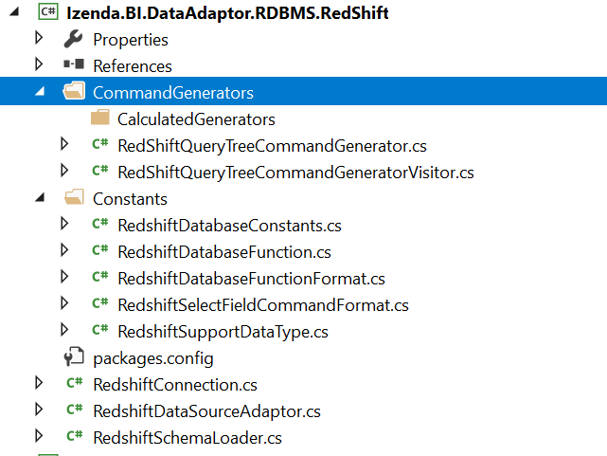

Figure : Structure of adaptor project at time create query tree command generator

Implementation of RedShiftQueryTreeCommandGenerator class:

using Izenda.BI.DataAdaptor.RDBMS.CommandGenerators;

using Izenda.BI.Framework.Components.QueryExpressionTree;

using Izenda.BI.Framework.Models;

namespace Izenda.BI.DataAdaptor.RDBMS.RedShift.CommandGenerators

{

public class RedShiftQueryTreeCommandGenerator : QueryTreeCommandGenerator

{

protected override string GenerateCommand(QueryTreeNode operand, FusionContextData context)

{

var visitor = new RedShiftQueryTreeCommandGeneratorVisitor();

visitor.ContextData = context;

operand.Accept(visitor);

return visitor.NodeData[operand.Id];

}

protected override void ApplyAdvancedSetting(FusionContextData context)

{

}

}

}

The operand parameter in GenerateCommand method will be a specific operator, the visitor (RedShiftQueryTreeCommandGeneratorVisitor) based on the context will generate corresponding SQL statement for that operand.

The ApplyAdvancedSetting method must be overridden to clear base implementation which is not supported in Redshift, basically it generates SQL command to set, begin and commit transaction but that syntax does not work on Redshift database.

Implemenation of RedShiftQueryTreeCommandGeneratorVisitor class:

using Izenda.BI.DataAdaptor.RDBMS.CommandGenerators;

namespace Izenda.BI.DataAdaptor.RDBMS.RedShift.CommandGenerators

{

public class RedShiftQueryTreeCommandGeneratorVisitor

: QueryTreeCommandGeneratorVisitor

{

//Will override operator command generator properties here

}

}

In next section, we will describe the way to identify what operator generator must be overridden and then declare overriding in this visitor class. Generally, this is place holder to indicate which operator generator has to re-write for giving correct SQL syntax on targeted database system.

In RedshiftDataSourceAdaptor, override QueryTreeCommandGenerator property to indicate new generator for Redshift database.

public override QueryTreeCommandGenerator QueryTreeCommandGenerator

{

get

{

return new RedshiftQueryTreeCommandGenerator();

}

}

The call hierarchy in base adaptor DataSourceAdaptor class will use this generator to generator SQL command instead of default QueryTreeCommandGenerator.

## Implement Custom Operator Command Generators

### Operator Command Generators Are Required to Override

In order to generate operator SQL statement and look up for other command generators inside current adaptor library, the overriding for classes in table below are required. In other word, based adaptor DataSourceAdaptor uses .NET Reflection to find out dependency generators that are ExpressionCommandGenerator, FilterCommandGenerator and NullToEmptyConverter as well.

|  |  |  |
| --- | --- | --- |
| # | Operator Command Generator | Description |
| 1 | ConvertNullToEmptyOperator  _CommandGenerator | Require overriding for reflection looks up generator for convert null to empty syntax. |
| 2 | GroupingOperatorCommandGenerator | Require overriding for reflection find out ExpressionCommandGenerator in adaptor library. |
| 3 | JoinOperatorCommandGenerator | Require overriding for reflection find out ExpressionCommandGenerator in adaptor library. |
| 4 | OperandCommandGenerator | Require overriding to provide overridden for SelectFieldCommandFormat |
| 5 | PagingOperatorCommandGenerator | Require overriding for reflection find out ExpressionCommandGenerator in adaptor library, and customize SQL paging syntax. |
| 6 | ProjectionOperatorCommandGenerator | Require overriding for reflection find out ExpressionCommandGenerator in adaptor library. |
| 7 | SelectFieldCommandGenerator | Require overriding for reflection find out ExpressionCommandGenerator in adaptor library. |
| 8 | SelectionOperatorCommandGenerator | Require overriding for reflection find out FilterCommandGenerator in adaptor library. |

Table : List of operator command generators have to be overridden on custom data adaptor

**RedhisftConvertNullToEmptyOperatorCommandGenerator**

In CommandGenerators folder, add RedshiftConvertNullToEmptyOperatorCommandGenerator.cs and modify to inherit from ConvertNullToEmptyOperatorCommandGenerator class.

using Izenda.BI.DataAdaptor.RDBMS.CommandGenerators;

namespace Izenda.BI.DataAdaptor.RDBMS.RedShift.CommandGenerators

{

public class RedshiftConvertNullToEmptyOperatorCommandGenerator : ConvertNullToEmptyOperatorCommandGenerator

{

public RedshiftConvertNullToEmptyOperatorCommandGenerator(QueryTreeCommandGeneratorVisitor visitor) : base(visitor)

{

}

public override SelectFieldCommandGenerator SelectFieldCommandGenerator

{

get

{

return new RedShiftSelectFieldCommandGenerator(visitor);

}

}

}

}

This class depends on RedShiftSelectFieldCommandGenerator which will be created later.

**RedshiftGroupingOperatorCommandGenerator**

In CommandGenerators folder, add RedshiftGroupingOperatorCommandGenerator.cs and modify to inherit from GroupingOperatorCommandGenerator class.

using Izenda.BI.DataAdaptor.RDBMS.CommandGenerators;

namespace Izenda.BI.DataAdaptor.RDBMS.RedShift.CommandGenerators

{

public class RedshiftGroupingOperatorCommandGenerator : GroupingOperatorCommandGenerator

{

public RedshiftGroupingOperatorCommandGenerator(QueryTreeCommandGeneratorVisitor visitor) : base(visitor)

{

}

public override string DefaultGroupBy

{

get

{

return string.Empty;

}

}

}

}

**RedshiftJoinOperatorCommandGenerator**

In CommandGenerators folder, add RedshiftJoinOperatorCommandGenerator.cs and modify to inherit from JoinOperatorCommandGenerator class.

using Izenda.BI.DataAdaptor.RDBMS.CommandGenerators;

using Izenda.BI.DataAdaptor.RDBMS.Constants;

namespace Izenda.BI.DataAdaptor.RDBMS.RedShift.CommandGenerators

{

public class RedshiftJoinOperatorCommandGenerator : JoinOperatorCommandGenerator

{

public RedshiftJoinOperatorCommandGenerator(QueryTreeCommandGeneratorVisitor visitor) : base(visitor)

{

}

protected override SelectFieldCommandFormat SelectFieldCommandFormat

{

get

{

if (selectFieldCommandFormat == null)

{

selectFieldCommandFormat = new RedShiftSelectFieldCommandFormat();

}

return selectFieldCommandFormat;

}

}

}

}

**RedshiftOperandCommandGenerator**

In CommandGenerators folder, add RedshiftOperandCommandGenerator.cs and modify to inherit from OperandCommandGenerator class.

This generator depends on expression command generator RedshiftDateAddTokenCommandGenerator and RedshiftCastTokenCommandGenerator, those generator class will be implemented in next section.

using Izenda.BI.DataAdaptor.RDBMS.CommandGenerators;

using Izenda.BI.DataAdaptor.RDBMS.Constants;

namespace Izenda.BI.DataAdaptor.RDBMS.RedShift.CommandGenerators

{

public class RedshiftOperandCommandGenerator : OperandCommandGenerator

{

private SelectFieldCommandFormat selectFieldCommandFormat;

protected override SelectFieldCommandFormat SelectFieldCommandFormat

{

get

{

if (selectFieldCommandFormat == null)

{

selectFieldCommandFormat = new RedshiftSelectFieldCommandFormat();

}

return selectFieldCommandFormat;

}

}

public override DateAddTokenCommandGenerator DateAddTokenCommandGenerator

{

get

{

return new RedshiftDateAddTokenCommandGenerator(null);

}

}

public override CastTokenCommandGenerator CastTokenCommandGenerator

{

get

{

return new RedshiftCastTokenCommandGenerator(null);

}

}

public RedshiftOperandCommandGenerator(QueryTreeCommandGeneratorVisitor visitor) : base(visitor)

{

}

}

}

**RedshiftPagingOperatorCommandGenerator**

In CommandGenerators folder, add RedshiftPagingOperatorCommandGenerator.cs and modify to inherit from PagingOperatorCommandGenerator class.

Overriding of this method has two purpose that supports to find out ExpressionCommandGenerator inside adaptor component and provide SQL paging syntax. In Redshift, it uses LIMIT and OFFSET keyword to handle that.

using Izenda.BI.DataAdaptor.RDBMS.CommandGenerators;

using Izenda.BI.Framework.Components.QueryExpressionTree;

using Izenda.BI.Framework.Components.QueryExpressionTree.Operator;

using Izenda.BI.Framework.Constants;

namespace Izenda.BI.DataAdaptor.RDBMS.RedShift.CommandGenerators

{

public class RedshiftPagingOperatorCommandGenerator : PagingOperatorCommandGenerator

{

public RedshiftPagingOperatorCommandGenerator(QueryTreeCommandGeneratorVisitor visitor) : base(visitor)

{

}

public override string GenerateCommand(QueryTreeNode treeNode, string childCommand)

{

var pagingOperator = (PagingOperator)treeNode;

// Modify sortingOperator and selectOperator

childCommand = childCommand.Replace(PlaceHolder.PagingField, "");

var query = @"SELECT * FROM({0}) x LIMIT {1} OFFSET {2}";

var paging = visitor.ContextData.Paging;

int offset = (paging.PageIndex - 1) * paging.PageSize;

return string.Format(query, childCommand, paging.PageSize, offset);

}

}

}

**RedshiftProjectionOperatorCommandGenerator**

In CommandGenerators folder, add RedshiftProjectionOperatorCommandGenerator.cs and modify to inherit from ProjectionOperatorCommandGenerator class.

using Izenda.BI.DataAdaptor.RDBMS.CommandGenerators;

namespace Izenda.BI.DataAdaptor.RDBMS.RedShift.CommandGenerators

{

public class RedshiftProjectionOperatorCommandGenerator : ProjectionOperatorCommandGenerator

{

public RedshiftProjectionOperatorCommandGenerator(QueryTreeCommandGeneratorVisitor visitor) : base(visitor)

{

}

}

}

Overriding this method only has one purpose that indicates .NET Reflection find ExpressionCommandGenerator and NullToEmptyConverter in adaptor library.

**RedshiftSelectFieldCommandGenerator**

In CommandGenerators folder, add RedshiftSelectFieldCommandGenerator.cs and modify to inherit from SelectFieldCommandGenerator class.

Overriding this class to indicate library and namespace follows convention to look up ExpressionCommandGenerator and NullToEmptyConverter generator.

using Izenda.BI.DataAdaptor.RDBMS.CommandGenerators;

namespace Izenda.BI.DataAdaptor.RDBMS.RedShift.CommandGenerators

{

public class RedshiftSelectFieldCommandGenerator : SelectFieldCommandGenerator

{

public RedshiftSelectFieldCommandGenerator(QueryTreeCommandGeneratorVisitor visitor) : base(visitor)

{

}

protected override string SpecificNamespaceForConvertNullToEmpty

{

get

{

return string.Format(ConvertNullToEmptyNamespace, ".RedShift", ".RedShift", this.GetType().Assembly.GetName().Name);

}

}

}

}

**RedshiftSelectionOperatorCommandGenerator**

In CommandGenerators folder, add RedshiftSelectionOperatorCommandGenerator.cs and modify to inherit from SelectionOperatorCommandGenerator class.

using Izenda.BI.DataAdaptor.RDBMS.CommandGenerators;

namespace Izenda.BI.DataAdaptor.RDBMS.RedShift.CommandGenerators

{

public class RedshiftSelectionOperatorCommandGenerator : SelectionOperatorCommandGenerator

{

public RedshiftSelectionOperatorCommandGenerator(QueryTreeCommandGeneratorVisitor visitor) : base(visitor)

{

}

}

}

Overriding this intends for reflection purpose such as load correct FilterCommandGenerator.

### Overriding Other Operator Command Generators

Most operator command generator in based adaptor component Izenda.BI.DataAdaptor.RDBMS was developed to adapt many relational database system as much as possible that means the generated SQL syntax can run on may RDBMS, but some of them can be different on your targeted RDBMS that case required you manually override the generator and provide correct SQL syntax on your database.

Your responsibility is comparing between SQL syntax is generated on based adaptor and standard syntax that your database system supports, if they are different you must override generator to generate correct SQL syntax.

One example for overriding generator and provide new SQL syntax is ResultLimitOperator, Izenda based adaptors generate SQL as SELECT TOP clause but we want to using LIMIT clause in Redshift to handle that logic so that require to override ResultLimitOperatorCommandGenerator.

In CommandGenerators folder, add RedshiftResultLimitOperatorCommandGenerator.cs and modify to inherit from ResultLimitOperatorCommandGenerator class then implement GenerateCommand method to provide new SQL syntax.

using Izenda.BI.DataAdaptor.RDBMS.CommandGenerators;

using Izenda.BI.Framework.Components.QueryExpressionTree;

using Izenda.BI.Framework.Components.QueryExpressionTree.Operator;

namespace Izenda.BI.DataAdaptor.RDBMS.RedShift.CommandGenerators

{

public class RedshiftResultLimitOperatorCommandGenerator : ResultLimitOperatorCommandGenerator

{

public RedshiftResultLimitOperatorCommandGenerator(QueryTreeCommandGeneratorVisitor visitor) : base(visitor)

{

}

public override string GenerateCommand(QueryTreeNode treeNode, string childCommand)

{

var resultLimitOperator = treeNode as ResultLimitOperator;

var query = @"SELECT * FROM ({0}) X LIMIT {1}";

var resultLimit = string.Format(query, childCommand, resultLimitOperator.Limit);

visitor.ContextData.TempData["resultLimit"] = resultLimit;

return resultLimit;

}

}

}

### Register Operator Command Generator in Visitor Class

To indicate adaptor uses new generator class we have to register them into visitor class. That simply override corresponding property for each Operator Command Generator and return instance of new generator.

Open RedshiftQueryTreeCommandGenerator.cs and add overridden properties like below:

public class RedshiftQueryTreeCommandGeneratorVisitor : QueryTreeCommandGeneratorVisitor

{

public override PagingOperatorCommandGenerator PagingOperatorCommandGenerator

{

get

{

return new RedshiftPagingOperatorCommandGenerator(this);

}

}

public override OperandCommandGenerator OperandCommandGenerator

{

get

{

return new RedshiftOperandCommandGenerator(this);

}

}

public override ProjectionOperatorCommandGenerator ProjectionOperatorCommandGenerator

{

get

{

return new RedshiftProjectionOperatorCommandGenerator(this);

}

}

public override SelectionOperatorCommandGenerator SelectionOperatorCommandGenerator

{

get

{

return new RedshiftSelectionOperatorCommandGenerator(this);

}

}

public override GroupingOperatorCommandGenerator GroupingOperatorCommandGenerator

{

get

{

return new RedshiftGroupingOperatorCommandGenerator(this);

}

}

public override ResultLimitOperatorCommandGenerator ResultLimitOperatorCommandGenerator

{

get

{

return new RedshiftResultLimitOperatorCommandGenerator(this);

}

}

public override JoinOperatorCommandGenerator JoinOperatorCommandGenerator

{

get

{

return new RedshiftJoinOperatorCommandGenerator(this);

}

}

public override ConvertNullToEmptyOperatorCommandGenerator ConvertNullToEmptyOperatorCommandGenerator

{

get

{

return new RedshiftConvertNullToEmptyOperatorCommandGenerator(this);

}

}

}

## Implement Expression Command Generator

### Analysis Overriding Expression Command Generator

This type of generator will generate SQL statement for calculated function such as AVG, SUM, ROUND...etc. It also generates SQL for function which are listed in DatabaseFunction class.

All expression command generator will be inherited IExpressionCommandGenerator, that is identifier of this generator type.

Generally, the calculated function and token are similar on most of database system, the base adaptor has already generated SQL adapt most of them except some calculation functions relate to date time format, specific in Redshift database we have DatePart and IsNull function which are configured with new syntax in RedshiftDataFunction, that required the generator for that function have to be overridden to provide the correct syntax and function name. That requires DateDartTokenCommandGenerator and IsNullTokenCommandGenerator have to be overridden for this adaptor.

Except the calculated function and token which have new syntax we have to override to provide correct functionality, the generators that are using supported data type configuration class DatabaseSupportDataType also is overridden because each database has different data types, in this adaptor that class is RedshiftSupportDatType class. Fortunately, we only have two generators in this type that are CastTokenCommandGenerator and ConvertTokenCommandGenerator, those generators will be overridden to provide custom DatabaseSupportDataType instance which is RedshiftSupportDatType.

The other configuration requires overriding some expression command generators is DatabaseConstants class, which is configured for datepart and timepart identifier name for date time value, we have not to configure specific for Redshift so no need to override the related generators, but if you are developing adaptor for the database that this configuration is changed you have to override related generators which are inherited from DateFunctionTokenCommandGenerator such as DatePartTokenCommandGenerator, DateAddCommandGenerator and DateDiffFunctionCommandGenerator.

On other hand, there is expression command generator processes for padding left alignment when formatting date time value, it is LpadTokenCommandGenerator. That generator was implemented by using Izenda Raw method IZENDA_CONCAT to combine padding character to left align date time value (for example, the day 1st will be formatted as 01st) but Redshift does not support CONCAT function with multiple parameters more than 2 and it contains the better function to handle that logic is LPAD function. That seems better to override this generator for replacing complex logic with IZENDA_CONCAT by LPAD function.

The last expression command generator has to be overridden to indicate correct adaptor identifier (for this adaptor is E285BFD1-F8D5-4BEB-A345-B3D2EF5A3DE8) for mapping function, it is MappingTokenCommandGenerator.

Summary of above analyses, the expression command generators are required to override is listed in table below:

|  |  |  |
| --- | --- | --- |
| # | Generator Name | Overriding Purpose |
| 1 | DateDartTokenCommandGenerator | Require to use new DatePart function: date_part |
| 2 | IsNullTokenCommandGenerator | Require to use new IsNull function: NVL |
| 2 | CastTokenCommandGenerator | Require to use data types configuration in RedshiftSupportDatType |
| 3 | ConvertTokenCommandGenerator | Require to use data types configuration in RedshiftSupportDatType |
| 4 | LpadTokenCommandGenerator | Override to replace complex logic of using IZENDA_CONCATE by more simple one LPAD function |
| 5 | MappingTokenCommandGenerator | Provide adaptor identifier GUID of Redshift data adaptor |

Table : List of expression command generator must be overridden in Redshift data adaptor

Following next sections, we will implement one by one above expression command generator and its consumer visitor class.

### Add generator and visitor class

In CommandGenerators folder, add new folder CalculatedGenerators.

In CalculatedGenerators add RedShiftExpressionCommandGenerator.cs below:

## Implement Filter Generator

*This is being documentation…*

# Create Redshift Data Source Adaptor Using ODBC Driver

*This is being documentation…*

## Introduction and Analysis

## Install Amazon Redshift ODBC Driver

## Implement Adaptor with OdbcConnection

### RedhisftConnection class

### RedhisftSchemaLoader class

### RedshiftDataAdaptor class

# Troubleshooting When Developing New Data Source Adaptor

*This is being documentation…*

## Debugging on Data Source Adaptor

## Investigate Issue by Analysis Izenda Log

## Troubleshooting for Limitation on ODBC Driver

# Testing New Data Adaptor From Izenda UI

On the UI, user can add connection strings and try some main features (connection string, data model, report, dashboard, …) to test the custom driver is configured correctly.

## Connection String

When the custom driver for a new server type is configured successfully, it will be automatically listed to the Data Server Type dropdown in the Connection String page.

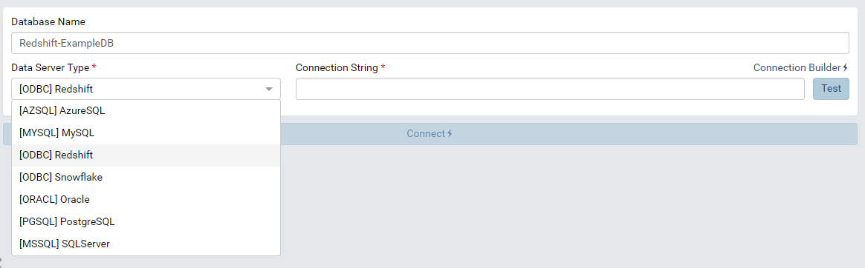

Figure : New server types are listed in Data Server Type dropdown

By selecting the new data server type, administrator can add this type of connection string to the system. Please see [Connection String Administrator Guide](http://localhost:1234/ui/doc_connection_string.html) for more details about adding connection string.

The image below show that a Redshift connection string is successfully add to Izenda system through custom driver.

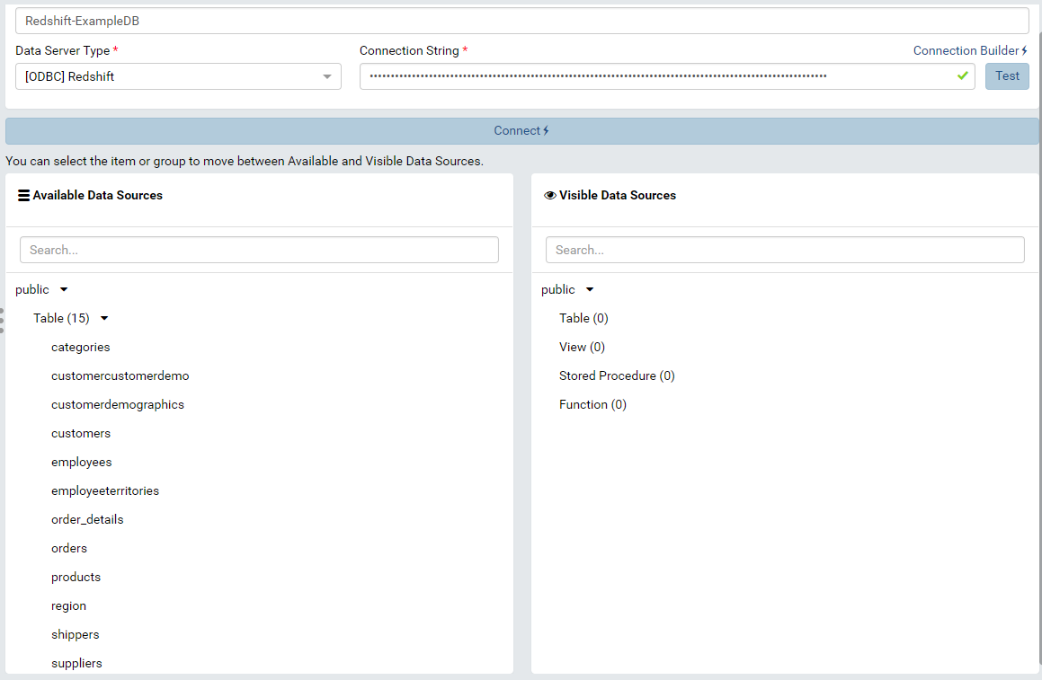

Figure : A Redshift connection string is connected successfully through Custom Driver

## Data Model

After adding connection string and choosing visible data sources, these data sources will be loaded in the specific tab of Data Model.

Administrator should check Tables, Views, Store Procedures, Functions and Relationship to make sure that the schema is loaded properly. Please see [Data Model/Tables, Views and Stored Procedures](https://www.izenda.com/docs/ui/doc_data_model_tables,_views_and_stored_procedures.html), [Data Model/Functions](https://www.izenda.com/docs/ui/doc_data_model_functions.html) and [Data Model/Relationships](https://www.izenda.com/docs/ui/doc_data_model_relationships_and_schema.html) for more details.

For example, the tables and relationships are loaded with all their fields in Tables tab in the below image.

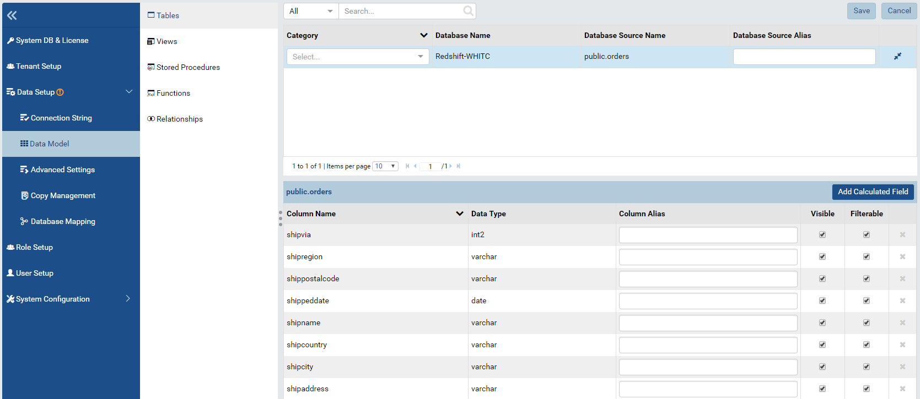

Figure : The selected table is loaded in the Data Model – Tables

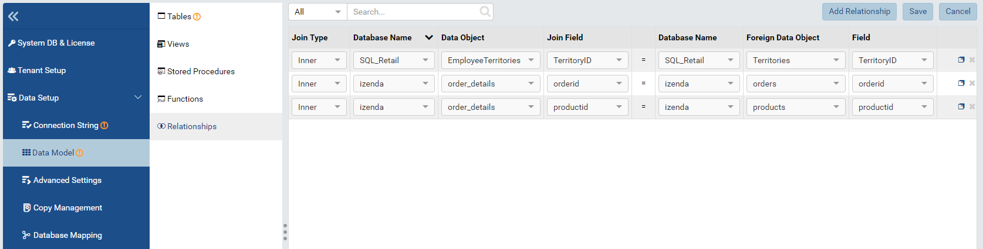

Figure : The relationships are loaded in Data Model - Relationships

Administrator can also Add custom view for the database that is connected by Custom driver. Please see [Custom View Setup Guide](https://www.izenda.com/docs/ui/doc_data_model_custom_view.html) for more details.

For instance, the custom view below to get all fields of order_details in Redshift database.

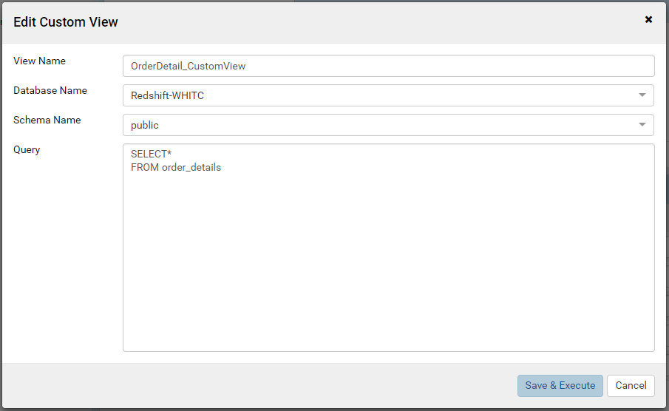

Figure : Add a custom view in Redshift

After pressing “Save & Execute” button, the query will be executed to get schema for the view. Then all fields will be shown in the slave section.

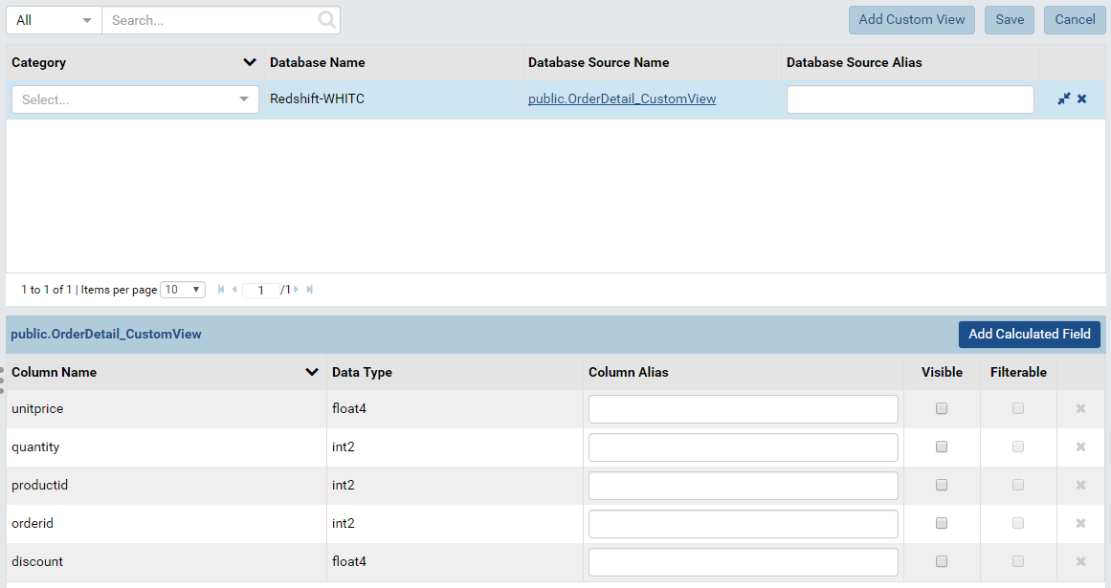

Figure : All fields of a custom view are shown in the slave section

## Report

All features relating to report should work correctly with the database connected by custom driver like all another types of database. Administrator can try some key feature as the following cases below:

### Case 1: Global report contains tenant field

Administrator can try sharing a global report that contains tenant field for a tenant and checking whether it retrieve data correctly at tenant level.

1. At System level, set up a database mapping for a tenant (WHITC in this example)

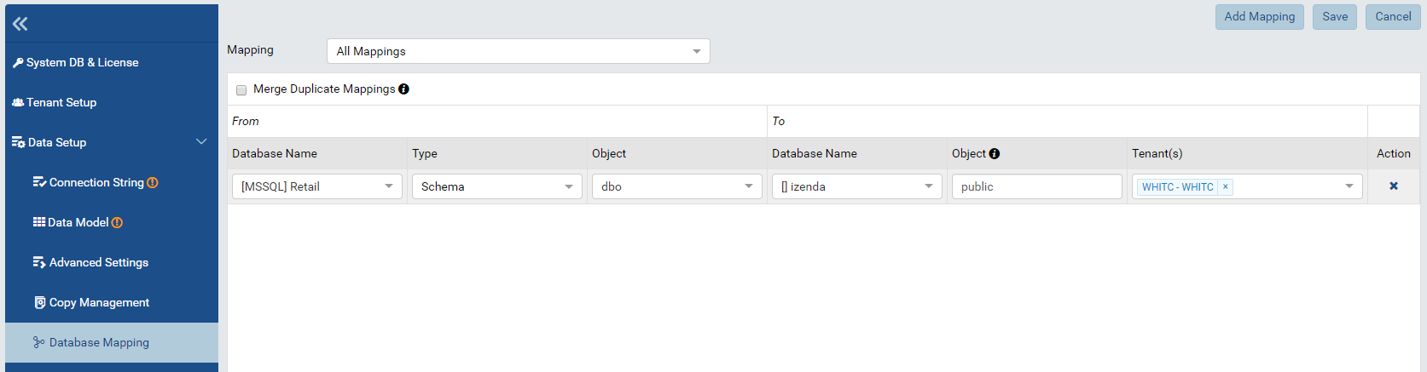

Figure : Database Mapping for tenant WHITC

1. Setting up tenant field. Please see [Advanced Setting - Security Settings](https://www.izenda.com/docs/ui/doc_advanced_settings.html#update-security-settings) for more details.

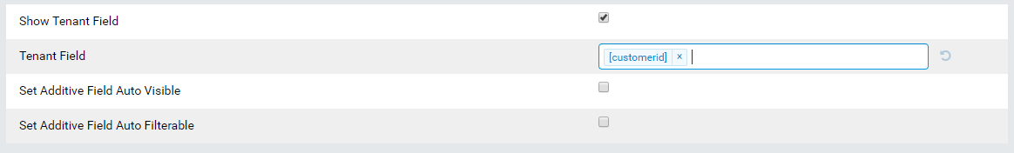

Figure : Setting field “customerid” as tenant field

1. Create a global report and add sharing.

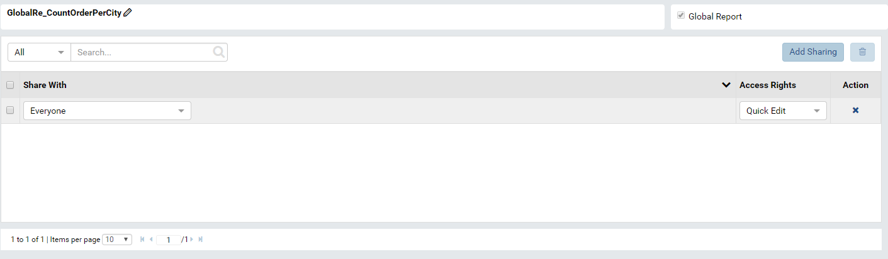

Figure : Add sharing for global report

1. View the below report at both system level and tenant level to check if the date is retrieve correctly.

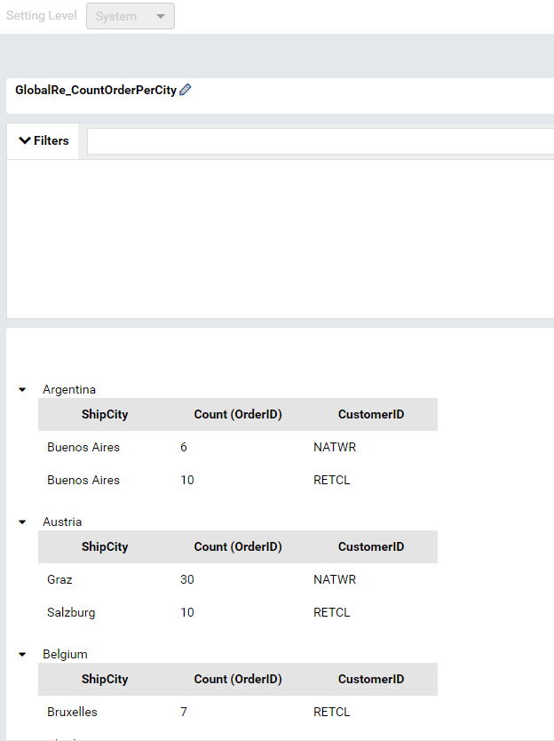

Figure : The Global report show all data at System level

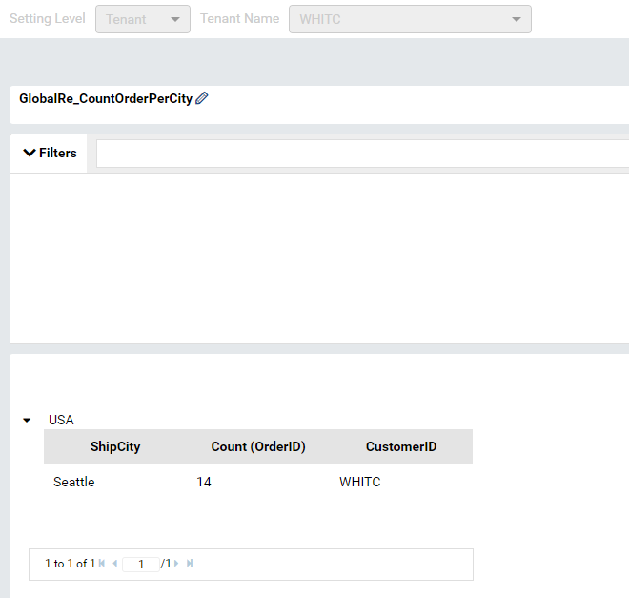

Figure : The Global report retrieve data for tenant WHITC

### Case 2: Report with filters

The images below show the report with filter that queries data from Redshift. Please see [Report Designer/Fields – Filter](https://www.izenda.com/docs/ui/doc_report_designer_fields.html#add-a-report-filter) for more details.

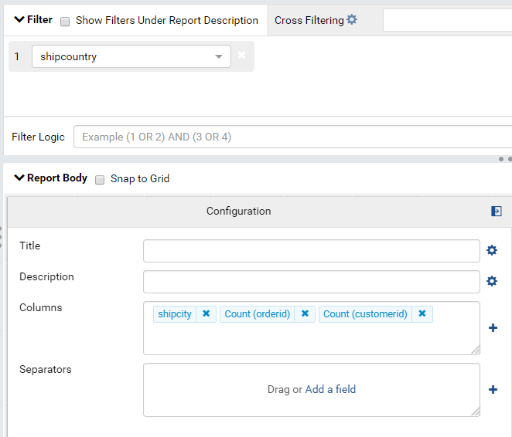

Figure : Report Designer backside of report part contains filter

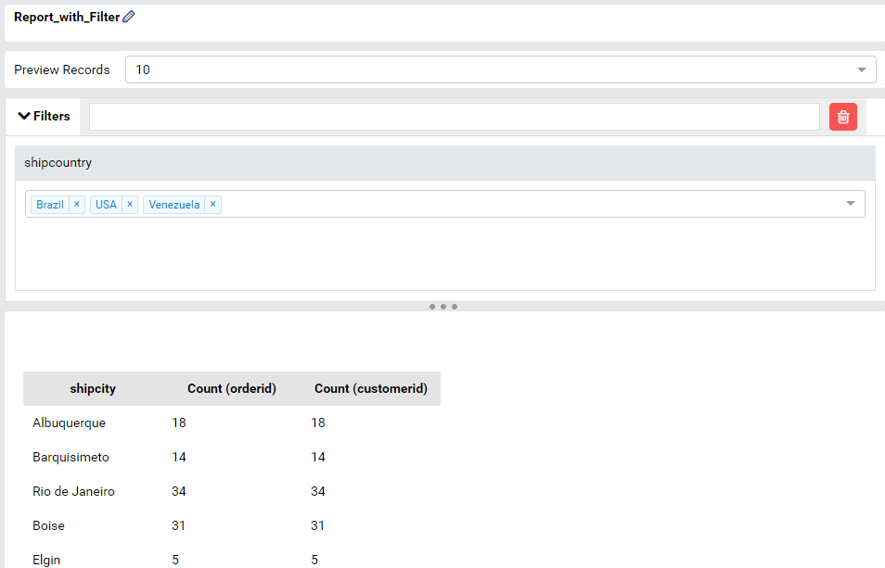

Figure : The report viewer contains filter

### Case 3: Report with grouping, aggregated function and sub total

Administrator can also try with the report containing aggregated function and subtotal following several steps below:

* Create a simple report with a couple of fields. For example, creating a report with 2 columns (shipcity and sum(freight)) and a separator (shipcountry)

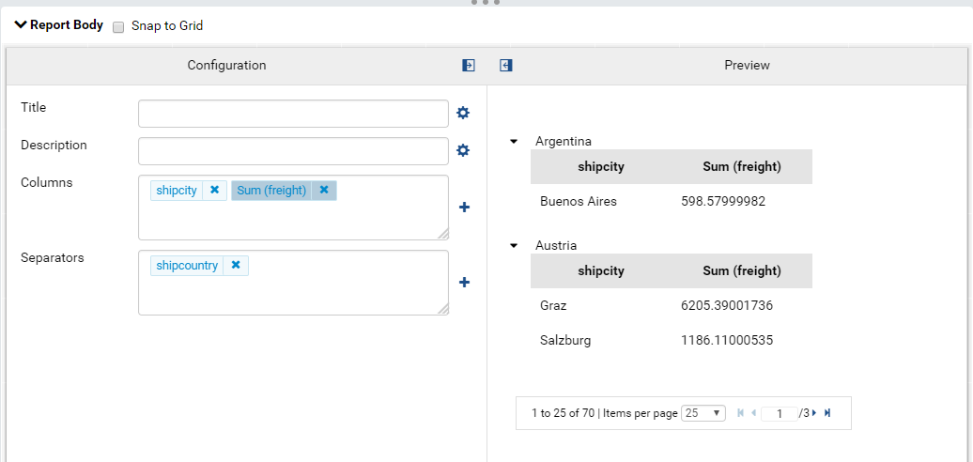

Figure : A grid report part contains 2 columns and a separator

* Add a Subtotal for a field. For example, add sum subtotal for sum(freight)

Please see [Sub Total](https://www.izenda.com/docs/ui/doc_grand_total_sub_total.html#sub-total) for more details.

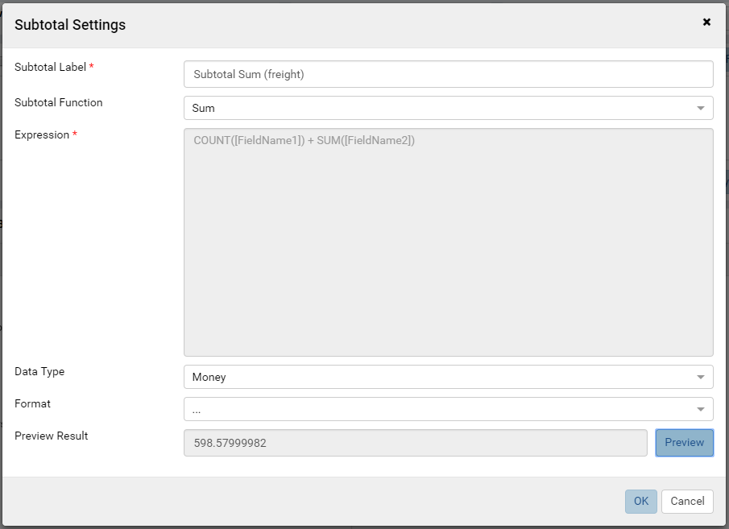

Figure : Add sum subtotal for sum(freight)

* Then save and view the report to ensure that all data is retrieved and calculated correctly.

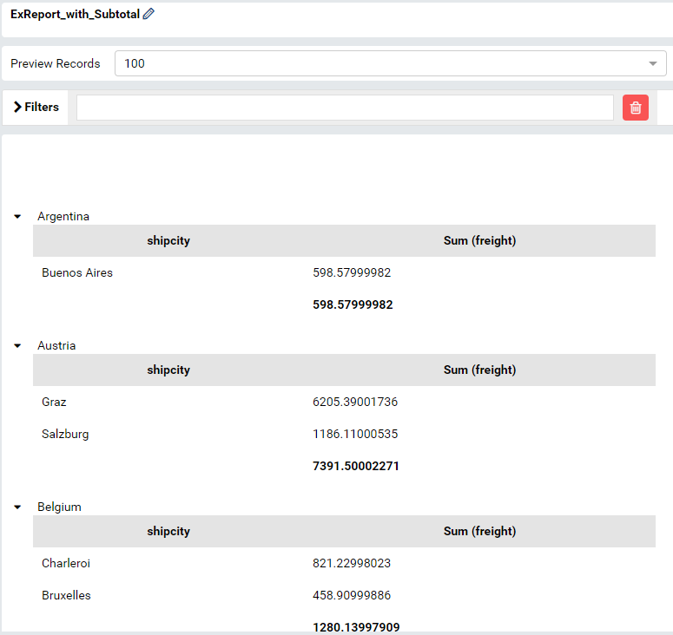

Figure : The report with aggregated and subtotal in viewer

### Case 4: Report with Calculated Field

The report retrieving data from database through Custom Driver should also work correctly with the [Calculated Field](https://www.izenda.com/docs/ui/doc_report_designer_fields.html#add-calculated-field).

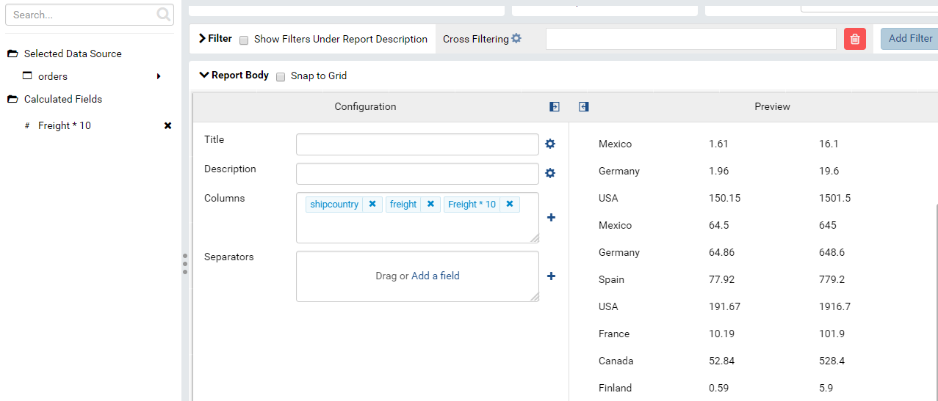

Figure : Report contains Calculated Field

### Case 5: Drilldown chart report part

The drilldown chart report part should work well when querying data from database that connected through Custom Driver.

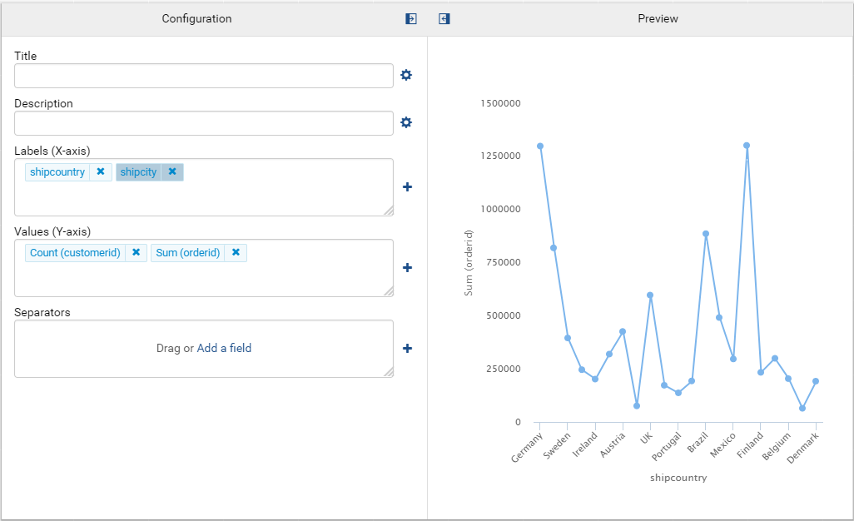

Figure : A drilldown chart querying data from Redshift database

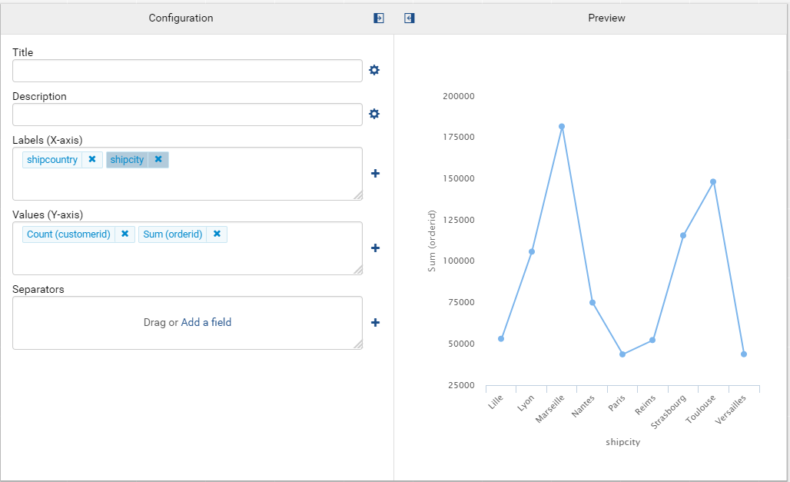

Figure : A chart querying data from Redshift after drill down on a Country

### Case 6: Exporting report

Exporting the chart report above in a couple of type, such as: PDF, CSV, … to make sure exporting feature work well with Custom Driver.

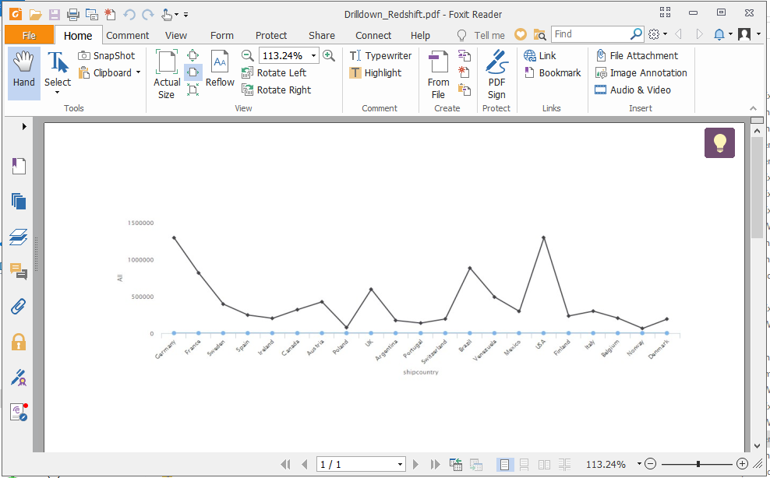

Figure : The PDF exporting file

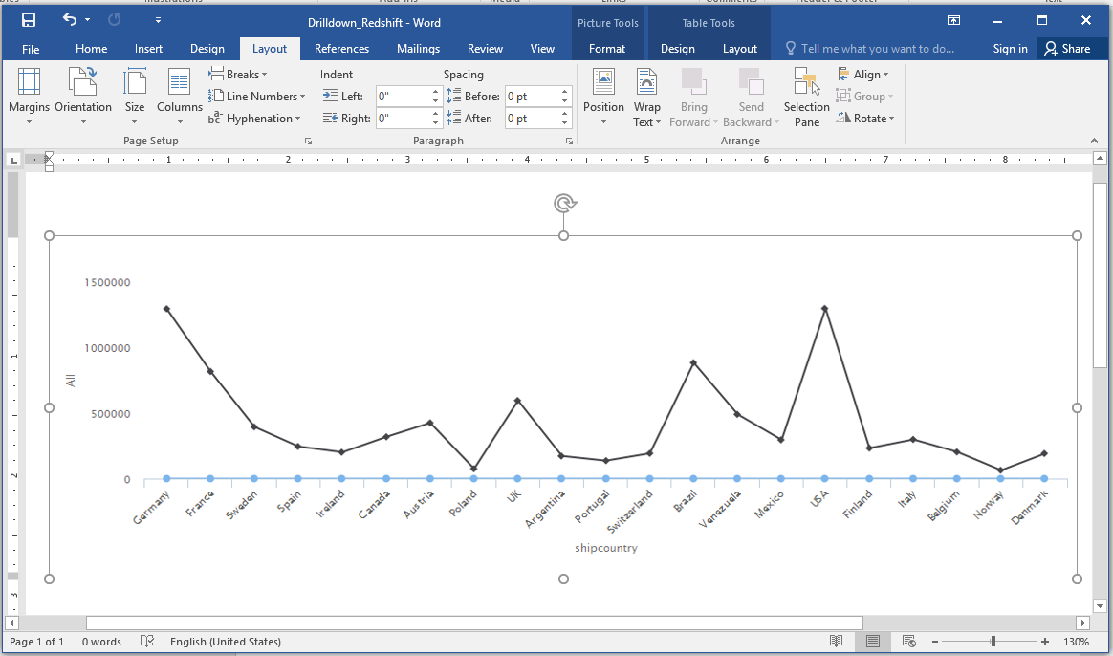

Figure : The Word exporting file

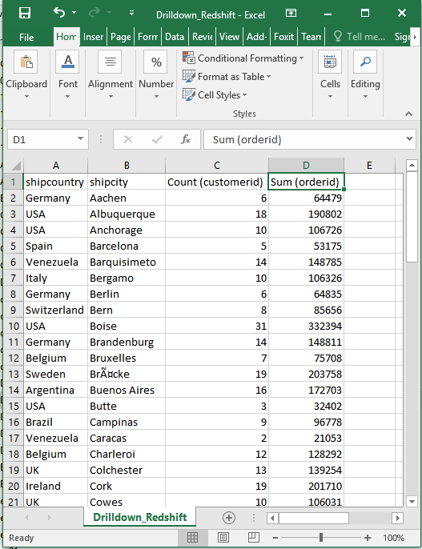

Figure : The CSV exporting file